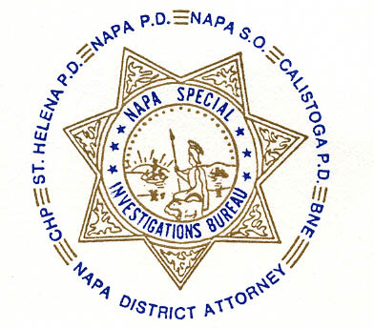NAPA SPECIAL INVESTIGATIONS BUREAU
GOVERNING BOARD
OPEN MEETING MINUTES
MAY 2013

ROLL CALL - The regular monthly meeting of the NSIB Governing Board was called to order on Thursday, May 23, 2013, at 3:00 p.m. at the Napa Police Department. Board members present included; Chairman Chief Richard Melton of the Napa PD, Sheriff John Robertson, Chief Mary Butler of the Napa County Probation Department, District Attorney Gary Lieberstein, Lieutenant Thomas Commander.

Also present at the meeting: Mike Donovan and Lieutenant Gary Pitkin.

Board members absent: Chief Mitchell Celeya of the Calistoga PD, Chief Jackie Rubin of the St. Helena PD, Captain Chris Childs of the CHP.

PUBLIC COMMENT
0 members of the public in attendance.
AGENDA ITEMS
MINUTES
Chief Butler moved that the minutes of the January Governing Board Meeting be approved as written. Sheriff Robertson made the second motion. Unanimously approved.

Donation request from D.A.R.E.
Pending clarification of past donations the Board requested the item be forwarded to the next meeting.

Proposed Buy Fund Increase
Lt. Commander authored and distributed a memo requesting approval to raise NSIB’s Buy Fund budget to $25,000. The Board advised it will review the request for the next fiscal year leaving the current budget amount at $18,000 for fiscal year 2013.

NSIB Annual Report review
The Board reviewed the 2012 Annual Report. It was decided to give a deadline of May 31 to propose changes after which time the report will be considered approved for distribution.

Napa County Auditor’s report for Fiscal Year 2011/2012
The Board reviewed the Auditor’s report. Chief Butler moved that the report be accepted as written. Sheriff Robertson made the second motion. Unanimously accepted.

Updated NSIB Logo
The Board reviewed and approved the updated NSIB logo.

OPEN DISCUSSION
None

ADJOURNMENT
There being no further business for the Open portion of the Governing Board Chief Butler moved that the meeting be adjourned. Mr. Lieberstein made the second motion. Unanimously approved at 3:25 p.m. to continue with Closed Session – Case Review/Planning (Government Code §54957.8).

Chief Richard Melton, Chairman

