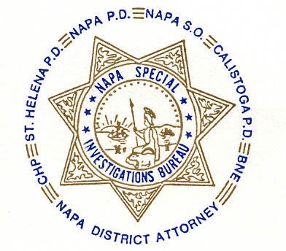NAPA SPECIAL INVESTIGATIONS BUREAU
Narcotic Task Force
P.O. Box 336 * Napa, CA 94559
707-253-4458

NSIB GOVERNING BOARD OPEN MEETING

AGENDA ITEMS

1. ROLL CALL - The regular monthly meeting of the NSIB Governing Board was called to order on May 16, 2007 at 11:20 a.m. at the Napa Police Department. Board members present included; Chairman Chief Richard Melton of the Napa PD, Sheriff Doug Koford, Chief Monty Castillo of the St. Helena PD, District Attorney Gary Lieberstein, Captain Mark Rasmussen of the CHP, Randy Bryant, SSAC of the Bureau of Narcotic Enforcement, and Bureau Commander Gary Pitkin. Also present was Ed Knutsen, Chief Investigator of the Napa County District Attorney’s Office. Board members absent included; Chief Mary Butler of the Napa County Probation Department, Chief Jonathan Mills of the Calistoga PD and John George, SAC of the Bureau of Narcotic Enforcement.

2. PUBLIC COMMENT - members of the public attended this meeting.

3. MINUTES – Chief Melton asked for a motion that the minutes of the Governing Board Meeting be approved as written. Sheriff Koford made the first motion and Captain Rasmussen seconded the motion unanimously approving the minutes.

4. Asset Forfeiture Distribution – Chief Melton asked for a motion to approve the Governing Board’s decision to amend the previous amount to be disbursed from $108,000 to $140,394. Chief Castillo made the first motion and Mr. Bryant made the second unanimously approving the decision.

5. Use of NSIB Trust Account – Commander Pitkin noted that in the past the donation of the NSIB Trust Account has been given to the Safe Schools/D.A.R.E. program. Although no formal requests have been received to date, Children’s Protective Services (CPS) and Child Abuse Prevention Council (CAPC) have expressed an interest in receiving monies to support a temporary emergency shelter for children and a Multi-Disciplinary Interview Center (MDIC) respectively. Commander Pitkin will be speaking with Linda Canan from CPS soon to discuss what amount would be helpful to the DEC program and the Temporary Emergency Shelter. Chief Melton expressed the need to disburse the money as efficiently as possible. DA Lieberstein will also be looking into what amount would be helpful for the Multi-Disciplinary Interview Center (MDIC) project and that it may also be matched by the DA’S Asset Forfeiture fund.

6. ADJOURNMENT

The next meeting of the NSIB Governing Board will be held on Wednesday, June 20, 2007 at 11:00 a.m. at the Napa Police Department.

________________________
Chief Richard Melton, Chairman

