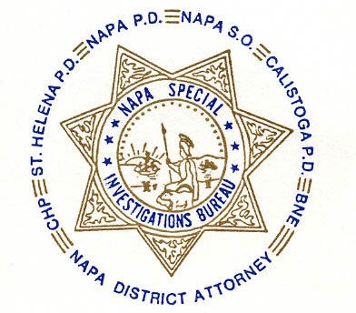

NAPA SPECIAL INVESTIGATIONS BUREAU
Narcotic Task Force
P.O. Box 336 Napa CA 94559
707-253-4458

NSIB GOVERNING BOARD OPEN MEETING

AGENDA ITEMS

1. ROLL CALL - The regular monthly meeting of the NSIB Governing Board was called to order on Thursday, March 19, 2009 at 10:30 a.m. at the Napa Police Department. Board members present included; Chairman Chief Richard Melton of the Napa PD, Sheriff Doug Koford, Chief Jonathan Mills of the Calistoga PD, Chief Monty Castillo of the St. Helena PD, Captain Mark Rasmussen of the CHP, SAC John George of the Bureau of Narcotic Enforcement and Bureau Commander Gary Pitkin. Board members absent included; Chief Mary Butler of the Napa County Probation Department and District Attorney Gary Lieberstein.

2. PUBLIC COMMENT - members of the public attended this meeting.

3. MINUTES – Sheriff Koford moved that the minutes of the Governing Board Meeting be approved as written. Chief Castillo seconded the motion, which was then approved unanimously.

Update on student interns – Commander Pitkin is waiting for information from Sonoma State University on the insurance compensation concerns for the students/interns and will report at the next Board meeting.

Update on Connor Ranch Note – DDA Roberts is in the process of drafting an offer and will report to the Board when it is complete.

Rescheduling of the next Governing Board Meeting – Commander Pitkin requested that the meeting scheduled for April be postponed to May as he will be on vacation. The Board approved the change to the next regularly scheduled meeting date which is Thursday, May 21, 2009.

4. ADJOURNMENT – 10:35 a.m. To continue with Closed Board Meeting.

________________________
Chief Richard Melton, Chairman

