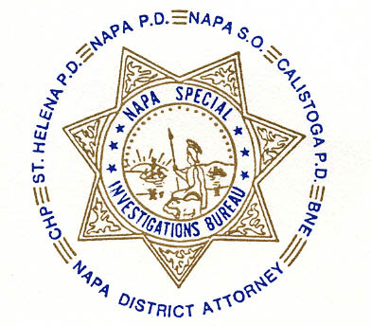NAPA SPECIAL INVESTIGATIONS BUREAU
GOVERNING BOARD
OPEN MEETING MINUTES
JANUARY 2013

ROLL CALL - The regular monthly meeting of the NSIB Governing Board was called to order on Thursday, January 24, 2013, 10:15 a.m. at the Napa Police Department. Board members present included; Captain Steve Potter for Chairman Chief Richard Melton of Napa PD, Sheriff John Robertson, Chief Mary Butler of Napa County Probation, Chief Mitchell Celeya of Calistoga PD, Assistant District Attorney Lee Philipson for District Attorney Gary Lieberstein, Lieutenant Thomas Commander, and Sergeant John Corrigan.

Also present at the meeting: Chief Investigator Mike Donovan from Napa County District Attorney’s Office.

Board members absent: Chief Jackie Rubin of St. Helena PD and Captain Mark Rasmussen of CHP.

PUBLIC COMMENT
0 members of the public in attendance.
AGENDA ITEMS
MINUTES
Mr. Philipson moved that the minutes of the October 2012 Governing Board Meeting be approved as written. Chief Butler made the 2nd motion, which was then unanimously approved.

Requested Increase in Buy Fund Budget
Lt. Commander requested an increase to NSIB’s Buy Fund Budget from $18,000 to $30,000 per fiscal year. Captain Potter moved that the Buy Fund Budget be increased upon receipt of a formal proposal drafted and presented at the next meeting. Sheriff Robertson made the 2nd motion which was then unanimously approved.

OPEN DISCUSSION
None

ADJOURNMENT
There being no further business for the Open portion of the Governing Board Captain Potter moved that the meeting be adjourned. Chief Butler made the 2nd motion. Unanimously approved at 10:25 a.m. to continue with Closed Session – Case Review/Planning (Government Code §54957.8).

Chief Richard Melton, Chairman

