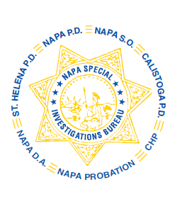
NAPA SPECIAL INVESTIGATIONS BUREAU
GOVERNING BOARD
OPEN MEETING MINUTES
FEBRUARY 2019

The regular open portion of the NSIB Governing Board quarterly meeting was called to order at 10:20 a.m. on Thursday, February 28, 2019.

ROLL CALL
Present or otherwise represented members included; District Attorney Allison Haley, Governing Board Chairperson, Sheriff John Robertson, Chief Robert Plummer, City of Napa Police Department, Chief Mary Butler, Napa County Probation Department, Chief Mitchell Celaya, Calistoga Police Department and Captain John Blencowe, California Highway Patrol.

Also present at the meeting: Lt. Amir Tabarsi and Sgt. Richard Henderson, California Highway Patrol
Board members absent: Chief Timothy Foley, St. Helena Police Department

PUBLIC COMMENT
0 members of the public in attendance.
AGENDA ITEMS
MINUTES – Sheriff Robertson moved that the minutes of the October 2018 Governing Board Meeting be approved as written. Chief Butler seconded the motion. Unanimously approved.

DRUG PREVENTION PRESENTATIONS
Lt. Greenberg discussed the Drug Prevention Presentations for the month of October, November and December and asked for requests for future presentations.

NSIB MOU Draft and Proposed NSIB Policy change
Lt. Greenberg briefed the Board on the revised NSIB MOU and the proposed change to Policy §2.30. Chief Celaya moved that the revised NSIB MOU and proposed policy change be approved as written. Sheriff Robertson seconded the motion. Unanimously approved.

OPEN DISCUSSION
None

ADJOURNMENT
There being no further business for the open portion of the Governing Board Chief Butler moved that the meeting be adjourned. Sheriff Robertson seconded the motion. Unanimously approved at 10:31 a.m. to continue with Closed Session – Case Review/Planning (Government Code §54957.8).

DA Allison Haley, Chairperson

