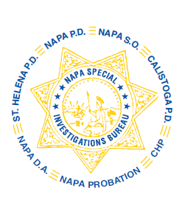
NAPA SPECIAL INVESTIGATIONS BUREAU
GOVERNING BOARD
OPEN MEETING MINUTES
DECEMBER 2013

ROLL CALL - The regular monthly meeting of the NSIB Governing Board was called to order on Thursday, December 19, 2013, 10:25 a.m. at Napa Police Department. Board members present included; Chairman Chief Richard Melton of the Napa PD, Sheriff John Robertson, Chief Mary Butler of the Napa County Probation Department, Chief Mitchell Celeya of the Calistoga PD, District Attorney Gary Lieberstein was represented by Assistant District Attorney Paul Gero, Lieutenant Gary Pitkin and Sergeant Mike Hunter.

Also present at the meeting: Undersheriff Jean Donaldson, NPD Captain Steve Potter, Captain Chris Childs of the CHP, and Chief DA Investigator Mike Donovan.

Board member(s) absent: Chief Jackie Rubin of the St. Helena PD

PUBLIC COMMENT – 0 members of the public in attendance.

AGENDA ITEMS
MINUTES – Chief Butler moved that the minutes of the October Governing Board Meeting be approved as written. Chief Celeya made the 2nd motion. Unanimously approved.

ADA GRANT APPLICATION 2013-2014 – No motion proposed. Forward to January 2014 meeting.

CRIME ANALYST – Lt. Pitkin proposed creating a full time Crime Analyst position to include tracking AB109 projects and statistics, property and drug crime patterns and trends, and other crime and intelligence analysis.

OPEN DISCUSSION – None

ADJOURNMENT – There being no further business for the Open portion of the Governing Board Chief Butler moved that the meeting be adjourned. Chief Celeya made the 2nd motion. Unanimously approved at 10:55 a.m. to continue with Closed Session – Case Review/Planning (Government Code §54957.8).

Chief Richard Melton, Chairman

