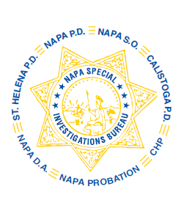
NAPA SPECIAL INVESTIGATIONS BUREAU
GOVERNING BOARD
OPEN MEETING MINUTES
AUGUST 2013

ROLL CALL - The regular monthly meeting of the NSIB Governing Board was called to order on Thursday, August 8, 2013 at 8:40 a.m. at Napa Police Department. Board members present included; Chairman Chief Richard Melton, Napa PD, Sheriff John Robertson, Chief Mary Butler, Napa County Probation Department, Chief Mitchell Celeya, Calistoga PD, Captain Chris Childs, CHP, District Attorney Gary Lieberstein, Lieutenant Gary Pitkin.

Also present at the meeting: Mike Donovan, Chief DA Investigator, Captain Steve Potter, NPD and Captain Gene Donaldson, NSD/American Canyon.

Board members absent: Chief Jackie Rubin, St. Helena PD

PUBLIC COMMENT
One member of the public in attendance (Kerana Todorov, Napa Valley Register).

AGENDA ITEMS
MINUTES
Mr. Lieberstein moved that the minutes of the August Governing Board Meeting be approved as written. Chief Butler made the 2nd motion. Unanimously approved.

OPEN DISCUSSION
The Board discussed the future roll and restructuring of NSIB as it relates to crime trends and other changes in law enforcement.

ADJOURNMENT
There being no further business for the Open portion of the Governing Board Mr. Lieberstein moved that the meeting be adjourned. Sheriff Robertson made the 2nd motion. Unanimously approved at 9:40 a.m. to continue with Closed Session – Case Review/Planning (Government Code §54957.8).

Chief Richard Melton, Chairman

