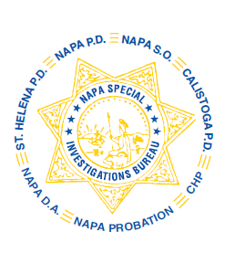
NAPA SPECIAL INVESTIGATIONS BUREAU
GOVERNING BOARD
OPEN MEETING MINUTES
MAY 2014

The regular open portion of the NSIB Governing Board monthly meeting was called to order on Thursday, May 22, 2014 at 8:35 a.m. at the Napa Police Department.

ROLL CALL
Present or otherwise represented members included; Chairman Chief Richard Melton of Napa PD represented by Captain Steve Potter, Sheriff John Robertson represented by Undersheriff Jean Donaldson, Chief Mary Butler of Napa County Probation Department, Chief Jackie Rubin of St. Helena PD, and Captain Chris Childs of CHP represented by Lt. Ezery Beauchamp.

Also present at the meeting: Captain Tracey Stuart of American Canyon PD
Board members absent: Chief Mitchell Celaya of Calistoga PD
Joined after roll call: District Attorney Gary Lieberstein

PUBLIC COMMENT
0 members of the public in attendance.
AGENDA ITEMS
MINUTES – Captain Potter moved that the minutes of the April Governing Board Meeting be approved as written. Lt. Beauchamp made the 2nd motion. Unanimously approved.

DRUG PREVENTION PRESENTATIONS
Lt. Pitkin discussed the Drug Prevention Presentations for the month of April.

OPEN DISCUSSION
Lt. Beauchamp noted that the CHP/NSIB position final approval is expected by the end of May or early June.

Mr. Lieberstein apprised the Board of a Prescription Drug Overdose conference he attended and expressed a desire to see a community forum of some kind for Napa County. The Board discussed the current programs in place and new ideas for public awareness. Lt. Pitkin noted that Marin County has a Prescription Drug Task Force and that he will contact them.

ADJOURNMENT
There being no further business for the open portion of the Governing Board Undersheriff Donaldson moved that the meeting be adjourned. Chief Butler made the 2nd motion. Unanimously approved at 8:40 a.m. to continue with Closed Session – Case Review/Planning (Government Code §54957.8).

Chief Richard Melton, Chairman

