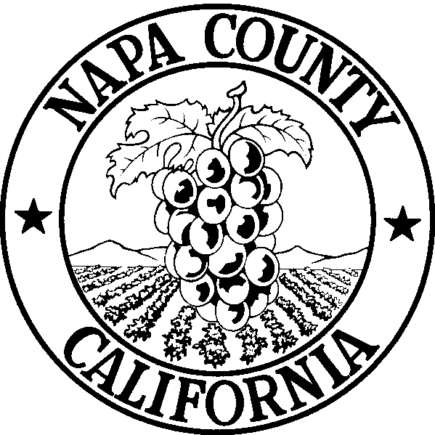
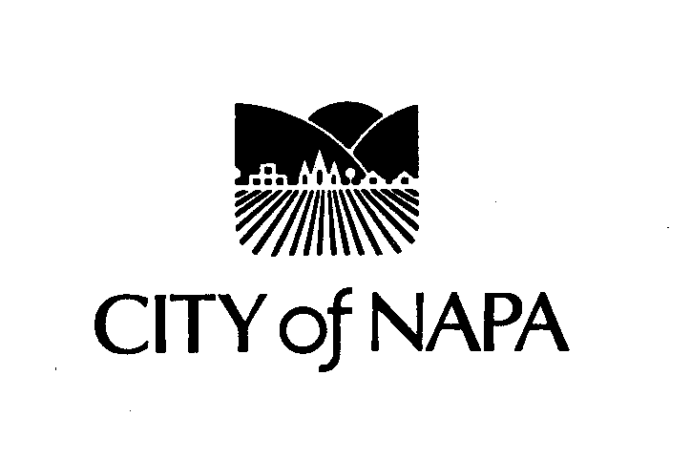
FINANCE DEPARTMENT
955 School Street
Mailing Address:
P.O. Box 660
Napa, CA 94559-0660
NAPA COUNTY ENVIRONMENTAL MANAGEMENT DEPARTMENT
1195 Third Street
Mailing Address:
1195 Third Street, Room 101
Napa, CA 94559

PRESS RELEASE

For Immediate Release: November 14, 2005

MEDIA CONTACTS:
Kevin Miller, Materials Diversion Administrator, City of Napa
(707) 257-9291 or pager (707) 491-4706/ kmiller@cityofnapa.org

Amy Garden, Environmental Resource Specialist, County of Napa
(707) 253-4471/ agarden@co.napa.ca.us

Napa County Receives Two Grants from the State
To Increase Recycling “Away From Home”

Napa, California – The City of Napa and the Upper Valley Waste Management Agency worked together to submit two successful grant proposals to the Department of Conservation to increase recycling opportunities “away from home”. Napa was fortunate to receive 2 of 13 grants awarded statewide giving Napa $160,000 out of $1.5 million in funding out of a very competitive field of 120 proposals statewide.

Napa already has implemented extensive single-stream recycling for residences, but wants to improve recycling opportunities at businesses and public venues so the public can recycle “away from home”. Both grants will enhance the new single-stream recycling program and were developed in coordination with the waste haulers Napa Recycling and Waste Services (NRWS) and Upper Valley Disposal and Recycling Service (UVDS) to benefit local businesses. Kate King, President/CEO Napa Chamber of Commerce stated, “The improved single-stream program enhanced with on-site technical assistance and free recycling containers for inside the businesses is a great idea. We also appreciate the encouragement of the businesses to recycle by using a financial award – that is real motivation!”

Increasing Recycling at Large Venues Grant - $82,000
This grant is awarded to The Upper Valley Waste Management Agency (Agency) to increase recycling of beverage containers at the four “large venues” in Napa:

- Copia – The American Center for Food, Wine, and the Arts
- Culinary Institute of America
- Napa County Fairgrounds
- Napa Valley Exposition (Expo)

All four of these locations have a high percentage of beverage containers and recyclables in the waste stream and have expressed interest in working with the Agency to increase the recycling rates at each site. The Agency and City staff will work with each venue to select a variety of

equipment to collect, transport, and consolidate recyclable materials including indoor and outdoor recycling bins. The programs will be customized to meet the needs of the venue including making sure that the bin design fits the décor and ambience of each site. The grant will pay for the equipment, staff time, and operating expenses such as desk side recycling baskets, printing, signs, and banners.

Increasing Recycling at Facilities Where 70+% of Waste is Beverage Containers - $78,000
The second grant will be managed by the City of Napa. This project will increase recycling at businesses and other locations that have 70+% or more of their waste comprised of beverage containers. Facilities that can benefit from this grant include restaurants and bars, gas stations, sports arenas, deli’s, convenience stores, gyms, and liquor stores. The City and the County will work closely with the waste haulers NRWS and NCRWS to identify qualifying businesses and offer the assistance. The grant will be for two years and each year 150 businesses will be added to the program. The businesses interested in participating will be provided interior recycling containers that are tailored to their needs. Starting in April 2006, the grant provides $1,000 per quarter in cash prizes for the most successful business recyclers.

Both grants provide multiple benefits to the community such as reducing the solid waste collection costs for participating businesses and making recycling more convenient for the businesses and their customers. Also, the City and south County and along with their haulers NRWS and NCRWS will receive more money as they each share in some of the revenue from the recyclables as outlined in the new garbage contracts. In addition to both grants having a goal of increasing recycling, they also hope to demonstrate to the state that businesses with high volumes of beverage containers are worthy of their own collection route which will help maintain the integrity of the recyclables by reducing “contamination” such as food waste. If successful, Napa will be a model for other jurisdictions in California on how to increase recycling “away from home” while improving the quality of the recyclables collected and the efficiency of the recycling program which will result in lower operational costs. It is also Napa’s goal to encourage recycling behavior for not only residents of this county, but for those many tourists that visit every year and can take home the story of how easy it was to recycle in Napa.

Tuesday November 15th is America Recycles Day and Napa can celebrate the success of the existing recycling program and hope for even greater recycling in the future with the support of the Department of Conservation, NRWS/NCRWS, UVDS, and the local business community.

________________________________
Jed Christensen, Finance Director

To: Post on City’s web page until December 30, 2005
Pub Info Coord Barry Martin e-mail
Napa Register
Napa Sentinel
KVON-KVYN – News Director
San Francisco Chronicle, Marin-Napa-Sonoma Friday editor (via e-mail)
Channel 28 Public Access TV 257-0581
Chamber of Commerce 226-1171
City Manager
Assistant City Manager (via e-mail)
Mayor and Council
City Clerk (via e-mail)
Public Works Director
Assistant Public Works Director (via e-mail)
Finance Director (via email)
Help Desk (via email)
Napa Recycling and Waste Services (NRWS) and NCRWS (via e-mail)
California Integrated Waste Management Board (via e-mail)
NVUSD Bus Dispatch 253-3557
Neal O’Haire, Napa County OES 253-4176
Pete Engel, NCTPA 259-8638
Central Dispatch 7277
Police Chief 7208
Fire Chief 258-7816
Karla Miller, Dept. of Conservation (via e-mail)
EcoNomics Inc. (via e-mail)
CalRecovery (via e-mail)
District 2 Senator Wesley Chesbro, (via e-mail)
District 7 Assemblywoman Noreen Evans (via e-mail)

