
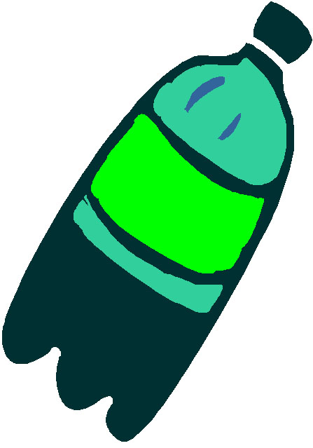
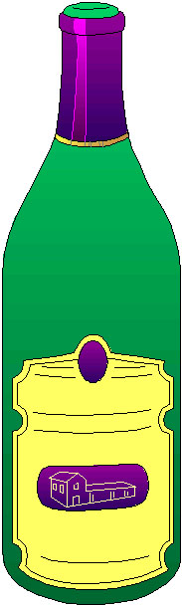
LINCOLN STREET, CALISTOGA
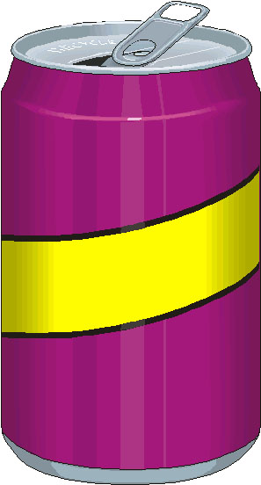
RECYCLING SUMMARY

1---2---3---4---5
Low contamination High Contamination
(About 100% Recyclables) (About 0% Recyclables)
Recycling Summary (10/26/04, 11/30/04, 2/1/05) -Tuesdays
Recycling  Container Location  (Updated) | Average  Contamination  Level  (see rating above) |  |  | Average % Full of all items in 32 gallon Container | Average % of Recyclables in 32 gallon Container | Average Weight of Recycled Bottles & Cans  (1 gal= 1lb)
#1 | 2 |  |  | 25% | 19% | 6 lbs
#2 | 1 |  |  | 47% | 47% | 15lbs
#3 | 1 |  |  | 3% | 3% | 1 lb
#4 | 1 |  |  | 40% | 40% | 13 lbs
#5 | 2 |  |  | 7% | 5% | 2 lbs
#6 | 1 |  |  | 53% | 53% | 17 lbs
#7 |  | 2 | 8% |  | 6% | 2 lbs
 |  |  |  |  | TOTAL WEIGHT: | 56 lbs (65 lbs/week)*  (3,397 lbs/year)*
*Because the recycling was checked 2 days before pick-up, the totals are based averages per week, extrapolated by averaging weight/container/day and multiplying it by 7 days.

Recycling Summary (4/21/05, 4/27/05, 4/28/05) –Thurs. (collection day)

Recycling  Container Location  (Updated) | Average  Contamination  Level  (see rating above) |  |  | Average % Full of all items in 32 gallon Container | Average %  of  Recyclables  in 32 gallon Container | Average Weight of Recycled Bottles & Cans  (1 gal= 1lb)
#1 | 1 |  |  | 58% | 58% | 19 lbs
#2 | 1 |  |  | 50% | 50% | 16lbs
#3 | 1 |  |  | 50% | 50% | 16lb
#4 | 1 |  |  | 33% | 33% | 11 lbs
#5 | 1 |  |  | 58% | 58% | 19lbs
#6 | No data
#7 |  | 1 | 25% |  | 25% | 8 lbs
 |  |  |  |  | TOTAL WEIGHT: | 89 lbs (104 lbs/week)*  (5,408 lbs/year)*
*Because there was one container missing data, averages per week & year were extrapolated by averaging weight per container and multiplying the figure by all 7 containers.

