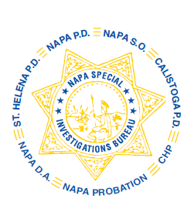
NAPA SPECIAL INVESTIGATIONS BUREAU
GOVERNING BOARD
OPEN MEETING MINUTES
SEPTEMBER 2013

ROLL CALL - The regular monthly meeting of the NSIB Governing Board was called to order on Thursday, September 26, 2013 at 11:10 am. Board members present included; Chairman Chief Richard Melton of the Napa PD, Sheriff John Robertson, Chief Jackie Rubin of the St. Helena PD, District Attorney Gary Lieberstein, and Lieutenant Gary Pitkin.

Also present at the meeting: Mike Donovan, Chief DA Investigator

Board members absent: Chief Mary Butler of the Napa County Probation Department, Chief Mitchell Celeya of the Calistoga PD and Captain Chris Childs of the CHP.

PUBLIC COMMENT
0 members of the public in attendance.
AGENDA ITEMS
MINUTES
Mr. Lieberstein moved that the minutes of the August 2013 Governing Board Meeting be approved as written. Sheriff Robertson made the 2nd motion. Unanimously approved.

OPEN DISCUSSION
None

ADJOURNMENT
There being no further business for the Open portion of the Governing Board Mr. Lieberstein moved that the meeting be adjourned. Chief Rubin made the 2nd motion. Unanimously approved at 11:12 am to continue with Closed Session – Case Review/Planning (Government Code §54957.8).

Chief Richard Melton, Chairman

