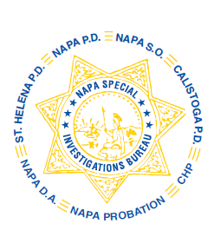
NAPA SPECIAL INVESTIGATIONS BUREAU
GOVERNING BOARD
OPEN MEETING MINUTES
OCTOBER 2013

ROLL CALL - The regular monthly meeting of the NSIB Governing Board was called to order on Thursday, October 31, 2013 at 11:20 a.m. at the Napa Police Department. Board members present included; Chairman Chief Richard Melton of the Napa PD, Sheriff John Robertson, Chief Mary Butler of the Napa County Probation Department was represented by Deputy Chief Amanda Gibbs, Chief Mitchell Celeya of the Calistoga PD, Chief Jackie Rubin of the St. Helena PD, District Attorney Gary Lieberstein, and Lieutenant Gary Pitkin.

Also present at the meeting: Captain Chris Childs of the CHP and Chief DA Investigator Mike Donovan.

PUBLIC COMMENT
0 members of the public in attendance.
AGENDA ITEMS
MINUTES
Chief Celeya moved that the minutes of the September Governing Board Meeting be approved as written. Sheriff Robertson made the 2nd motion. Unanimously approved.

OPEN DISCUSSION – None

ADJOURNMENT
There being no further business for the Open portion of the Governing Board Chief Celeya moved that the meeting be adjourned. Chief Rubin made the 2nd motion. Unanimously approved at 11:25 a.m. to continue with Closed Session – Case Review/Planning (Government Code §54957.8).

Chief Richard Melton, Chairman

