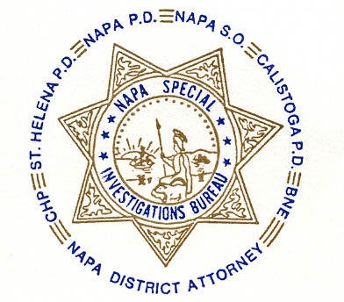NAPA SPECIAL INVESTIGATIONS BUREAU
GOVERNING BOARD

OPEN MEETING MINUTES
MAY 2011

ROLL CALL - The regular monthly meeting of the NSIB Governing Board was called to order on Thursday, May 26, 2011, at 10:50 a.m. at the Napa PD. Board members present included; Chairman Chief Richard Melton of the Napa PD, Sheriff Doug Koford was represented by Undersheriff John Robertson, Chief Mary Butler of the Napa County Probation Department, District Attorney Gary Lieberstein, Captain Mark Rasmussen of the CHP, Chief Jonathan Mills of the Calistoga PD, SAC Steve Ladeck of Bureau of Narcotic Enforcement and Bureau Commander Richard Russell. Board members absent included: Interim Chief Michael Johnstone of the St. Helena PD. Also present at the meeting was: Chief Investigator Mike Donovan of the Napa County D.A. Office

PUBLIC COMMENT – 0 members of the public attended this meeting.

AGENDA ITEMS

MINUTES – Captain Rasmussen moved that the minutes of the April Governing Board Meeting be approved as written. Chief Mills seconded the motion, which was then approved unanimously.

OPEN DISCUSSION

ADJOURNMENT – To continue with Closed Session – Case Review/Planning (Government Code §54957.8)

_____________________________
Chief Richard Melton, Chairman

