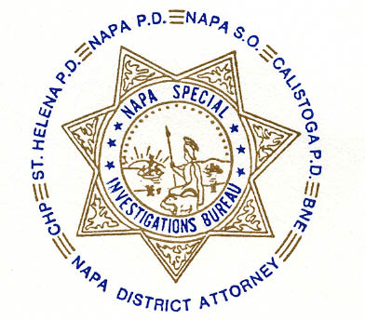NAPA SPECIAL INVESTIGATIONS BUREAU
GOVERNING BOARD
OPEN MEETING MINUTES
JUNE 2013

ROLL CALL - The regular monthly meeting of the NSIB Governing Board was called to order on Thursday, June 27, 2013, at 10:45 a.m. at the Napa Police Department. Board members present included; Chairman Chief Richard Melton of the Napa PD, Sheriff John Robertson, Chief Mary Butler of the Napa County Probation Department, Chief Mitchell Celeya of the Calistoga PD, Chief Jackie Rubin of the St. Helena PD, Captain Chris Childs of the CHP, District Attorney Gary Lieberstein, Lieutenant Gary Pitkin, and Lt. Thomas Commander.

Also present at the meeting: D.A. Chief Investigator Mike Donovan and NPD Officer Omar Salem.

Board members absent: None

PUBLIC COMMENT
0 members of the public in attendance.
AGENDA ITEMS
MINUTES
Mr. Lieberstein moved that the minutes of the May Governing Board Meeting be approved as written. Chief Butler made the 2nd motion. Unanimously approved.

D.A.R.E. Program
No decision made by the Board. Forwarded to Closed meeting to consider funding donation.

Legacy Program
Napa Police Officer Omar Salem explained the future goals and accomplishments to date of the Legacy Program. No decision made by the Board. Forwarded to Closed meeting to consider funding donation.

Strategic Planning
The Board discussed scheduling time for further planning on the JPA and MOU. Chief Melton will email the Board members with dates for August.

OPEN DISCUSSION
None

ADJOURNMENT
There being no further business for the Open portion of the Governing Board Chief Butler moved that the meeting be adjourned. Mr. Lieberstein made the 2nd motion. Unanimously approved at 11:30 p.m. to continue with Closed Session – Case Review/Planning (Government Code §54957.8).

Chief Richard Melton, Chairman

