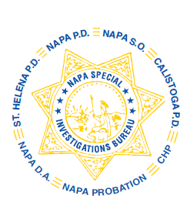
NAPA SPECIAL INVESTIGATIONS BUREAU
GOVERNING BOARD
OPEN MEETING MINUTES
FEBRUARY 2014

ROLL CALL
The regular monthly meeting of the NSIB Governing Board was called to order on Thursday, February 27, 2014 at 11:00 a.m. at the Napa Police Department. Board members present included; Chairman Chief Richard Melton of the Napa PD, Sheriff John Robertson, Captain Chris Childs of the CHP, District Attorney Gary Lieberstein, Lieutenant Gary Pitkin and Sergeant Mike Hunter.

Also present at the meeting: Undersheriff Jean Donaldson, NPD Captain Steve Potter and Chief DA Investigator Mike Donovan.

Board members absent: Chief Mary Butler of the Napa County Probation Department, Chief Mitchell Celaya of the Calistoga PD and Chief Jackie Rubin of the St. Helena PD.

PUBLIC COMMENT
0 members of the public in attendance.
AGENDA ITEMS
MINUTES
No quorum. Approval of the January meeting minutes is referred to the next Governing Board meeting.

CHP Participation
Lt. Pitkin advised the Board that the addition of Officer Patrick Ensley to NSIB is working very well.

OPEN DISCUSSION
Mr. Lieberstein discussed programs the DA’s Office has supported with its asset forfeiture disbursements.

Sheriff Robertson advised the Board that a request for funding in the amount of $5,000 has been awarded to Safe Schools/D.A.R.E.

ADJOURNMENT
There being no further business for the Open portion of the Governing Board the meeting was adjourned at 11:10 a.m. to continue with Closed Session – Case Review/Planning (Government Code §54957.8).

Chief Richard Melton, Chairman

