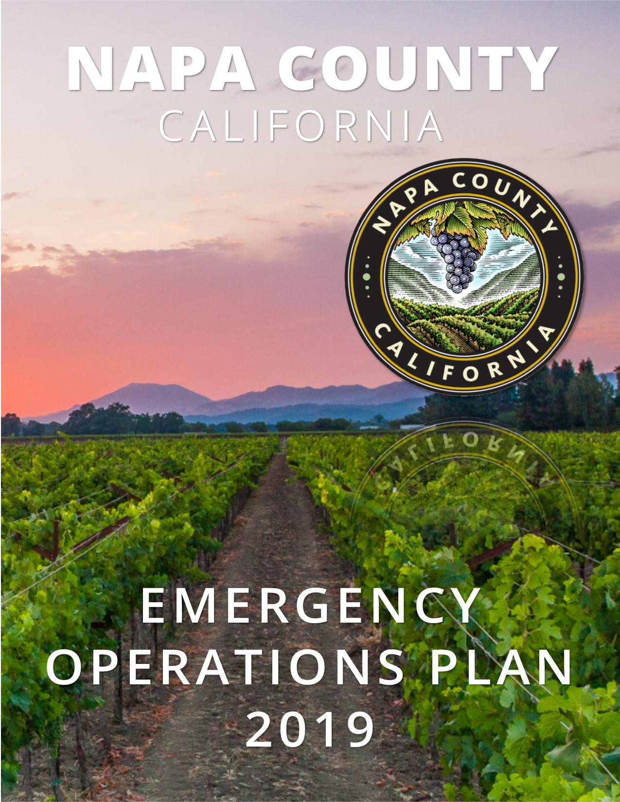

Page Intentionally Left Blank

A. Administrative Material 5
Overview 5
Letter of Promulgation 6
Approval and Implementation 7
Record of Changes and Distribution 8
B. Introduction, Purpose, Scope, Situations, and Assumptions 9
Introduction 9
Governance 9
Regional Emergency Management 10
Purpose 10
Scope 11
Situation Overview 11
Community Profile 13
Hazard Analysis 16
Risk Assessment Matrix 17
Planning Assumptions 25
Whole Community Approach 25
C. Concept of Operations 26
Emergency Operations Center (EOC) 31
EOC Primary Functions 31
Activation 32
Proclaiming an Emergency 36
Notification Process: 37
Mutual Aid Coordination 37
Deactivation 37
D. Information Collection, Analysis, and Distribution 39
Information dissemination within the EOC 39
Information communicated outside of the EOC 39
Alert and Warning 39
Mass Notification Systems 40
E. Organization and Assignment of Responsibilities 41
Overview of Key Functions 41
Department Responsibilities 41
Crosswalk of Emergency Functions and Agency Responsibilities 41
F. Direction, Control, and Coordination 43
Coordination with Field-Level Incident Command Posts 43
Coordination with Cities in the OA (Local level) 43
Coordination with Special Districts/Utilities Providers in the OA 43
Coordination with Voluntary Organizations 44
Napa County (OA-level) 44
Coordination with Cal OES Coastal Region/Mutual Aid Region II (Regional level) 44
Coordination with Cal OES Headquarters (State-level) 44
G. Considerations 45
Disaster Service Workers 45
Volunteer Management 45
People with Access and Functional Needs 46
ADA Grievances 47
H. Transition to Recovery 48
I. Phases of Emergency Management 52
Prevention 52
Preparedness 52
Response 53
Recovery 54
Mitigation 55
J. Training and Exercises 56
K. Plan Development and Maintenance 57
L. Authorities and References 58
Appendix A: Acronyms 60
Appendix B: Definitions 62

Administrative Material

Overview
This document is the revised Napa County Emergency Operations Plan (EOP). This plan supersedes any previous plan(s) promulgated for this purpose. It provides a framework for Napa County to use in performing emergency functions before, during, and after an emergency event, natural disaster, or technological incident. This EOP supports the National Incident Management System (NIMS) and the Standardized Emergency Management System (SEMS). The County shall work together with State, Federal, and local agencies to prevent, prepare for, respond to, and recover from incidents regardless of cause, size, or complexity effectively and efficiently. The EOP supports the overall mission of Napa County Office of Emergency Services (Napa County OES). Napa County OES endorses and promulgates this document as the revised Napa County Emergency Operations Plan (EOP).
Napa County OES is responsible for the development and maintenance of the EOP. This plan is intended to be in accordance with all existing Federal, State, and local statutes. All Federal, State, and local laws supersede the policies and procedures listed in this plan. This plan will be tested, revised, and updated as required. All recipients are requested to advise OES regarding recommendations for improvement.
The revised Napa County EOP has been reviewed and is hereby approved.
The following emergency ordinances authorizing Emergency Services and other functions described in this plan can all can be found at https://library.municode.com/ca/napa_county/codes/code_of_ordinances)
- 2.80.080 Emergency Plan
- 5.14.060 Emergency Alert
- 2.80.070 Emergency Organization
- 8.56.090 Emergency Removal
- 16.04.820 Emergency Abatement
- 2.36.100 Emergency Purchases
- 2.100.260 Emergency Employment
- 2.80.065 Public Health Emergency
- 2.80.020 Emergency Definition
- 12.04.130 Emergency Work
- 8.70.066 Emergency Action
- 2.80.030 Emergency Services Council- Created- Membership

Letter of Promulgation

July 2020

Napa County Executive Office
1195 Third Street, Suite 310
Napa, CA 94559
www.countyofnapa.org

The preservation of life and property is an inherent responsibility of all levels of government. As disasters can occur in devastating form at any time, Napa County must provide safeguards, which may save lives, while minimizing property damage. This will be accomplished through planning, preparedness measures, and training. Sound emergency plans carried out by knowledgeable and well-trained personnel can and will minimize losses.
While no plan can prevent death and destruction, good plans carried out by knowledgeable and well-trained personnel can and will minimize losses. This plan establishes the emergency organization, assigns tasks, specifies policies and general procedures, and provides for coordination of planning efforts of the various emergency staff and service elements utilizing the Standardized Emergency Management System and the National Incident Management System.
This plan was developed for each Napa County department, local special districts with emergency services responsibilities, and the cities within Napa County. The intent of the EOP is to provide direction on how to respond to an emergency from the outset through an extended response, and into the recovery process.
Once adopted, this plan is an extension of the State of California Emergency Plan. It will be reviewed and tested periodically and revised as necessary to meet changing conditions.
The Napa County Board of Supervisors gives its full support to this Emergency Operations Plan (EOP) and urges all public employees and individuals to prepare for times of emergency before they occur.

______________________________________
Diane Dillon
County Board of Supervisors Chairman

Approval and Implementation
Napa County has a commitment to the safety of its residents. Their safety and security depend upon the continuation of public services before, during, and after an emergency/disaster.
Napa County OES is mandated by federal, state, and local laws to ensure that mitigation efforts are enhanced, preparedness is encouraged, responsiveness is assured, and recovery is achieved efficiently and effectively, before, during, and after man-made or natural disasters (i.e., wildland fires, earthquakes, terrorism, tsunamis, chemical spills, floods, etc.) which may occur within the County.
One of the primary responsibilities of OES is to develop an emergency management plan, update the plan and maintain a record of changes. This plan should address, to the extent possible, all emergency response functions of local governmental departments, agencies, public officials, and other public and private organizations during emergencies/disasters.
This plan was developed with the cooperation of the County Disaster Council, County, Municipal, and Special District departments and agencies such as law enforcement, fire, healthcare facilities, and public works, and the Napa Valley Community Organizations Active in Disaster (COAD), including those advocating for Access and Functional Needs (AFN). These organizations play a pivotal and functional role in responding to emergencies/disasters.
The EOP was developed using FEMA’s Comprehensive Preparedness Guide Version 2.0. The EOP consists of a basic plan, its attachments, and functional annexes.
On behalf of the planning committee:

______________________________________ ______________________________________
Minh C. Tran Jason Holley
County Executive Officer American Canyon City Manager
______________________________________ ______________________________________
Michael Kirn Steve Potter
Calistoga City Manager Napa City Manager
______________________________________ ______________________________________
Mark Prestwich Steven Rogers
St. Helena City Manager Yountville Town Manager
______________________________________ ______________________________________
Kerry John Whitney Chair, Napa County Emergency Services Council
County Risk and Emergency Services Manager

Record of Changes and Distribution
The version number format X.x.x indicates the level of change since the previous version:
2.2.0
⤷ Maintenance: content correction, title or name change, typographical error
⤷ Minor: revision or addition of an annex; modification of an existing section
⤷ Major: substantial update, reorganization, or doctrinal change.
This list reflects changes made since the issuance of version 2.0.
Date | Description

Introduction, Purpose, Scope, Situations, and Assumptions

Introduction
The Napa County Emergency Operations Plan (EOP) addresses the planned response to extraordinary emergency situations affected that Napa Operational Area (OA). The OA includes the six incorporated cities and towns, special districts, and unincorporated areas that fall within the geographic boundaries of Napa County. The EOP describes a comprehensive emergency management system that provides for a planned response to disaster situations associated with natural disasters, technological incidents, terrorism, pandemics/emerging infectious diseases, and nuclear-related incidents. It delineates operational concepts relating to various emergency situations, identifies components of the County’s emergency management organization within the Standardized Emergency Management System (SEMS), and describes the overall responsibilities for protecting life and property and assuring the overall wellbeing of the population. This plan is not intended to address the day-to-day emergencies or field-level responses, for which there are well established procedures among first responder agencies.
When emergencies extend beyond the capabilities of the local first responders at the field-level, they will seek additional support through existing Mutual Aid Agreements and/or request support resources from local and regional agencies. If these emergencies occur in unincorporated areas of the county, across multiple jurisdictions, or require regional or state assistance, the Napa County OES is called upon to coordinate requests for assistance, set up mobile command centers, activate the Operational Area (County) Emergency Operations Center (EOC), help prioritize emergency resources, and manage critical information flow for responders, news media and the general public.
When significant emergency events overwhelm local capabilities, additional systems outlined in the EOP may need to be activated, beginning with the proclamation of a local emergency. County and city employees, in their role as disaster service workers, may be called upon to assist in the activation, operation, or deactivation of the systems and procedures outlined in the EOP. Therefore, personnel must be knowledgeable of the overall plan.

Governance
The Napa County Operational Area governance structure fulfilled by the Napa County Emergency Services Council, as defined by county code 2.80.030, consists of the following:
- The chairman of the board of supervisors, who shall be chairman.
- The director of emergency services, who shall be vice-chairman.
- The assistant director of emergency services.
- Such chiefs of emergency services as are provided for in a current emergency plan of the county, adopted pursuant to this chapter.
- Such representatives of civic, business, labor, veterans, professional or other organizations having an official emergency responsibility as may from time to time be appointed by the board of supervisors and serving at the pleasure of the board.
Napa County Office of Emergency Services (OES), a division of the County Executive Office, is the County’s emergency management agency. As such, it is the lead agency that fulfills the county’s requirements under the Emergency Services Act (Government Code § 8550-8668). Its mission is to promote, facilitate, and support the County of Napa and the Operational Area (OA) efforts to prepare for, mitigate against, respond to, and recover from disasters. In order to achieve this mission, Napa County OES directly supports the Emergency Services Council, through the maintaining of functional subcommittees, partnering with emergency management stakeholders within the OA, and participating in emergency management activities with regional partners.
The Emergency Services Council’s duty is to develop and recommend for adoption by the board of supervisors, emergency and mutual aid plans and agreements and such ordinances and resolutions and rules and regulations as are considered necessary to implement such plans and agreements. The emergency services council shall meet upon call of the chairman or, in his absence from the county or inability to call such meeting, upon call of the vice-chairman.
Emergency Services Council Duties:
- Reviews & approves plans & agreements, including the Operational Area plan
- Approves Office of Emergency Services grant funds
- Meet annually at minimum

Regional Emergency Management
The Napa OA is within Mutual Aid Region II and the Cal OES Coastal Region. The Coastal Region manages and coordinates information and resources among OAs within the mutual aid region and also between the OA and the State Level. Whenever Napa’s OA EOC is activated the Cal OES Regional Administrator will activate the Regional Emergency Operations Center (REOC) and notify Cal OES Headquarters. The REOC will then coordinate resource requests from the Napa OA to unaffected OAs within the affected region, or, if resources are not available within the affected region, resource requests are forwarded to the State Operations Center (SOC) for coordination. The Coastal Region has assigned an Emergency Services Coordinator that represents Cal OES and supports and participates in the OA’s emergency management activities. The OES Coastal Region Office may also serve as a Disaster Support Area (DSA) when necessary.
In accordance with SEMS, Cal OES Coastal Region meets and coordinates with OAs within the Region on a regular basis by hosting the Mutual Aid Regional Assistance Committee (MARAC). Napa County OES represents the Napa OA at these meetings.
The Bay Area Urban Areas Security Initiative (UASI) is another important regional emergency management partner. The UASI program sustains and improves the region’s capacity to prevent, protect against, respond to, and recover from terrorist incidents and catastrophic through participation in an advisory capacity. Napa OA is not a voting member of the UASI Approval Authority; however, it is included in Bay Area UASI’s North Bay Hub, which includes the Operational Areas of Marin, Sonoma, Napa, and Solano County.
Bay Area UASI is an established forum for collaborating and coordinating with all other Bay Area OAs. Regional working groups are in place to address Interoperable Communications, Risk Management and Information Sharing, Medical and Health Preparedness, Regional Catastrophic Preparedness Grant Program (RCPGP), Chemical/Biological/Radiological/Nuclear/Explosive grant funding received from the Homeland Security Grant Program (HSGP) through the Federal Emergency Management Agency (FEMA).

Purpose
This EOP addresses Napa County's coordinated and planned response to extraordinary emergency situations associated with natural, technological, and human-caused emergencies or disasters within or affecting Napa County. This plan is the principal guide for Napa County’s response to, management of, and recovery from real or potential emergencies and disasters occurring within its designated geographic boundaries. Specifically, this plan is intended to:
- Facilitate multi‐jurisdictional and interagency coordination in emergency situations, particularly between local government, the Operational Area (the geographic boundary of Napa County), and appropriate state and federal agencies and entities.
- Set forth lines of authority and organizational relationships and shows how actions will be coordinated
- Interface with applicable local, state, and federal plans.
- Describe the County’s approach to the emergency management phases of prevention, preparedness, response, recovery, and mitigation.
- Identify the components of the County’s Emergency Management Organization and describes the processes that will be activated to effectively prepare for, respond to, and recover from major emergencies and disasters.
- Establish the operational concepts associated with the coordination of resources and support to field responders in an emergency; the proclamation process; the management of the Emergency Operations Center (EOC) activities; systems used to coordinate the request for and integration of resources during an emergency; and the processes toward short‐term and long‐term recovery.
- Establish the organizational framework for implementation of the California Standardized Emergency Management System (SEMS) and the National Incident Management System (NIMS) within Napa County.
This EOP takes a Function-Based approach to planning. This approach identifies the common functions that a jurisdiction must perform during emergencies. Function-based planning defines the function to be performed and some combination of government agencies and departments responsible for its performance as a course of action. As such, the plan is supported by functional and hazard-specific annexes. These annexes describe the operational actions, roles, and responsibilities of departments, agencies, and supporting organizations of a particular function.

Scope
The Napa County EOP applies to any extraordinary emergency associated with any hazard, natural or human-caused, which may affect any area within the County’s geographic boundaries and result in situations that require planned, coordinated responses by multiple agencies or jurisdictions. The Napa County EOP establishes an emergency organization and defines responsibilities for all agencies and individuals, public and private, having roles in emergency preparedness, response, recovery and/or mitigation in the County. The Napa County EOP is designed to be compliant with SEMS and NIMS and will be used in coordination with the State Emergency Plan and National Response Framework. More information on how the scope of the plan aligns within the SEMS response levels can be found in the Concept of Operations section.

Situation Overview
The community profile and threat/hazard analysis summary sections below provide an overview of the situation facing the County. These sections identify the risks and or unique circumstances about the County that help emergency planners and city executives make preparedness decisions. A full geographic and demographic profile for Napa County can be found in Section 4.3 of the Napa County Multi-Jurisdictional Hazard Mitigation Plan. The MJHMP includes mapping and more detailed analysis of the County’s hazard vulnerability.

Geographic
Napa County is located in the North Bay Area of California, north of San Pablo Bay and 50 miles north of San Francisco. It is one of the nine San Francisco Bay Area counties and one of four North Bay counties. Contiguous counties include Solano, Sonoma, Lake and Yolo. It is located in the Cal OES Coastal Region and Mutual Aid Region II.
The County extends from the Napa River Delta on the south and west to the Mayacamas mountain range. It contains extensive agricultural lands in its valley, hillsides, and south county areas. Napa County has played and is still playing, a large part in the building of Northern California as a center for agriculture, tourism, and light industry. The operational area of Napa County is approximately 788 square miles in area and varies in terrain from bayfront to mountainous to marsh.
Demographic
The United States Census Bureau estimated Napa County’s population to be 139,417 in 2018, an estimated 2.1% increase since 2010. (U.S. Census Bureau, 2019) . In the context of all-hazards preparedness and response planning, at-risk individuals (often used interchangeably with “vulnerable populations”) are defined federally as “children, pregnant women, senior citizens, and other individuals who have access or functional needs in the event of a public health emergency.”(42 U.S.C. § 2802(b)(4)(B)(2019)) Examples of these populations may include but are not limited to individuals with disabilities, individuals who live in institutional settings, individuals from diverse cultures, individuals who have limited English proficiency or are non-English speaking, individuals who are transportation disadvantaged, individuals experiencing homelessness, individuals who have chronic medical disorders, and individuals who have pharmacological dependency. About 6.8% of individuals in Napa County are below the poverty level. (U.S. Census Bureau, 2019).
The most vulnerable residents (in terms of income and housing condition) to natural hazards are outside Calistoga and St. Helena, south of Yountville and on the outskirts of Napa. Age is another important indicator of social vulnerability; Based on the 2017 American Community Survey, 17.4% of Napa County’s population is 65 or older. In addition, 11.6% of the County’s over-65 population have disabilities of some kind and 2.4% have incomes below the poverty line. An estimated 21.5% of the County’s population is 18 or younger. About 3.7% of children under the age of 18 are living below the poverty level. Based on the 2017 American Community Survey, 17.4% of Napa County’s population is 65 or older. In addition, 11.6% of the County’s over-65 population have disabilities of some kind and 2.4% have incomes below the poverty line. An estimated 21.5% of the County’s population is 18 or younger. About 3.7% of children under the age of 18 are living below the poverty level.
Farm workers may be particularly vulnerable during a hazard event, especially those non-English speaking and those living in temporary worker housing. In the north coastal agricultural region of California, which includes Napa County, there are approximately 17,700 agricultural workers, of whom 6,100 work in the grape sector. (California Employment Development Department, 2019) Moreover, 3,750 of the farmworkers in Napa County are estimated to be migrant workers. (U.S. Dep't of Ag, 2017) Non-English or limited-English speakers may have difficulty understanding emergency information as a result of language and literacy barriers.
Another vulnerable population is individuals with access and functional needs that may interfere with their ability to access or receive medical care before, during, or after a disaster or emergency. Napa County integrates the access and functional needs of these individuals using the CMIST framework, described in the Access & Functional Needs Annex.

Economic
Agriculture and tourism are the major local industries. Napa County is the center of California’s wine industry the County is particularly susceptible to economic losses to the wine industry in the event of a hazard event. The Napa County wine industry accounts for $9.4 billion in economic impact in Napa County. According to the Bureau of Labor Statistics, in June 2019 there were 82,323 jobs in all industries in Napa County.
Agriculture includes a wide diversity of varietal grapes, specialty crops, and other limited livestock operations common to the fertile Napa Valley. The wine industry fuels tourism, with extensive production in over 400 wineries. Napa State Hospital and the State of California Veterans Home are also major employers.
Transportation
There are three major highways that run through Napa County. Highway 29 connects the five incorporated cities running roughly north up the Napa Valley connecting to Vallejo in the south and continuing north as the main north-south artery to Lake County. State Highway 128 (east and west) cuts through the County in the east through the Lake Berryessa area and to the northwest connecting the Napa Valley to the Knights, Alexander, and Anderson Valleys. Highway 12 connects the southern third of the County to the I-80 corridor and the Central Valley on the east and connects Napa and Sonoma counties on the west. A network of County roads connects the various communities to these major arteries. Silverado Trail, a major County-maintained road, provides a very useful north-south route up the Valley floor to Highway 29. The Napa Valley Wine Train maintains a tourist rail line from Napa to St. Helena along the old S&P right of way. The California Northern crosses the southern third of the County connecting to the Union Pacific mainline at Cordelia and continuing north to Eureka. The Napa County Airport, between the cities of Napa and American Canyon, serves as an executive-style airport with limited charter capability for both passengers and freight.

Community Profile
In 2018, Napa County, CA had a population of 139,000 people with a median age of 40.8 and a median household income of $75,341. Between 2016 and 2018 the population of Napa County fell from 140,823 to 139,253, a 0.112% decrease and its median household income grew from $74,609 to $75,341, a 0.98% increase.
The population of Napa County is 77.2% White Alone, 33.7% Hispanic or Latino, and 7.4% Asian Alone. 35.4% of the people in Napa County speak a non-English language, and 88.1% are U.S. citizens.
The median property value in Napa County is $655,600, and the homeownership rate is 63.1%. Most people in Napa County commute by driving alone, and the average commute time is 22.8 minutes. The average car ownership in Napa County is two cars per household.

Population Fact | Napa County Operational Area | State of California
Population, 2018/20 | 139,253 | 38,066,920
Non-Institutionalized Population | 137,294 | 37,551,064
Total County Disabled Population | 15,347 | 3,851,442
County Percentage with a Disability  - Hearing Difficulty  - Vision Difficulty  - Cognitive Difficulty  - Ambulatory difficulty | 11.2%  - 4.9%  - 5.3%  - 5.3%  - 5.3% | 10.3%  - 4.5%  - 4.2%  - 5.6%  - 6.1%
Persons under 5 yrs | 5.7% | 6.3%
Persons 5 to 19 yrs | 19.2% | 19.6%
Persons 20 to 44 yrs | 31.5% | 35.5%
Persons 45 to 64 yrs | 27.6% | 25.1%
Persons over 65 yrs | 16.0% | 13.2%
Ethnicity  - White  - Black or African American  - American Indian & Alaska Native  - Asian  - Native Hawaiian & other Pacific Islander  - Hispanic or Latino (of any race) | - 77.2%  - 2.1%  - 0.5%  - 7.4%  - 0.3%  - 33.0% | - 60.6%  - 5.8%  - 0.75%  - 14.1%  - 0.39%  - 38.7%
Language  - Speak only English  - Speak a language other than English  - Spanish or Spanish Creole  - Other Indo-European Languages  - Asian and Pacific Island Languages  - Other Languages | - 64.6%  - 35.4%  - 27.9%  - 2.5%  - 4.7%  - 0.3% | - 55.96%  - 44.04%  - 28.7%  - 4.4%  - 9.9%  - 1.0%
Total Housing Units | 27,776 | 13,996,299
Occupied Housing Units | 26,978 | 12,888,128
Vacant Housing Units | 798 | 1,108,171
For Seasonal, Recreational, or Occasional Use | 168 | 383,658
Homeowner vacancy rate (percent) | 0.8% | 1.2%
Rental vacancy rate (percent) | 1.9% | 3.6%
Median Home value of owner-occupied housing units | $655,600 | $443,400
Median Household Income, past 12 months | $75,341 | $67,169
Families below poverty level, percent, 2017 | 5.1% | 13.3%

The economy of Napa County employs 71,100 people. The largest industries in Napa County are Health Care & Social Assistance (9,719 people), Manufacturing (9,196 people), and Accommodation & Food Services (7,699 people), and the highest paying industries are Public Administration ($75,877), Mining, Quarrying, & Oil & Gas Extraction ($73,464), and Utilities ($71,838).
Median household income in Napa County is $75,341. Males in Napa County have an average income that is 1.26 times higher than the average income of females, which is $57,252. The income inequality in Napa County (measured using the Gini index) is 0.5, which is higher than the national average.
From 2016 to 2017, employment in Napa County grew at a rate of 1.74%, from 69,900 employees to 71,100 employees. The most common jobs held by residents of Napa County, by number of employees, are Management Occupations (9,000 people), Office & Administrative Support Occupations (8,267 people), and Sales & Related Occupations (7,005 people). Compared to other counties, Napa County has an unusually high number of residents working as Farming, Fishing, & Forestry Occupations (5.39 times higher than expected), Building & Grounds Cleaning & Maintenance Occupations (1.37 times), and Food Preparation & Serving Related Occupations (1.34 times).

Hazard Analysis
The 2020 Napa County Multi-Jurisdictional Hazard Mitigation Plan includes a detailed risk assessment and hazard analysis that measures the potential impact to life, property, and the economy from natural hazards. The planning team considered and analyzed a broad set of hazards presented in planning documents and occurring historically in Napa County. The MJHMP does not include detailed analysis of human-caused threats, though this abbreviated hazard analysis does include hazard profiles for de-energization, pandemic, and terrorism. Fifteen different hazards were identified based on this thorough review, including:
- Agricultural Threats
- Climate Change
- Dam Failure
- De-energization
- Drought
- Earthquake
- Flood
- Landslide
- Levy Failure
- Pandemic Disease
- Severe Weather/Winter storm
- Terrorism and technological hazards
- Tsunami
- Slope Failure
- Wildfire

Risk Assessment Matrix
The MJHMP Planning Committee’s hazard prioritization process combines historical data, local knowledge, and consensus opinions to produce a matrix that illustrates whether each profiled hazard is an extreme, high, or medium priority. The criteria below were used to evaluate hazards and identify the highest risk hazard in Napa County.
Minor - very few injuries, if any. Only minor property damage & minimal disruption on quality of life. Temporary shutdown of critical facilities.
Limited - minor injuries only. Approx. 10% or less of property in disaster footprint damaged or destroyed. Complete shutdown of critical facilities for more than one day.
Critical - multiple deaths/injuries possible. Between 25% and 50% of property in disaster footprint is damaged or destroyed. Complete shutdown of critical facilities for more than one week.
Catastrophic - high number of deaths/injuries possible. More than 50% of property in affected area damaged or destroyed. Complete shutdown of critical facilities for 30 days or more.

Highly likely - 100% annual probability. Or Likely to occur every year in your lifetime.

Likely - between 10% & 100% annual probability. Or will occur several times in your lifetime.

Possible - between 1% & 10% annual probability. Or Likely to occur sometime in your lifetime.

Unlikely - less than 1% annual probability. Or unlikely but possible to occur in your lifetime.
Risk Assessment Matrix Definitions
Probability Rating
The likelihood of a hazard event occurring within a time period?
Impact Rating
In terms of injuries, damage, or death, would you anticipate impacts to be minor, limited, critical, or catastrophic when a significant hazard event occurs? The impact could be in terms of one hazard event (flooding from a culvert failure) or a large-scale event (multiple rivers flooding) in the same jurisdictional boundary.

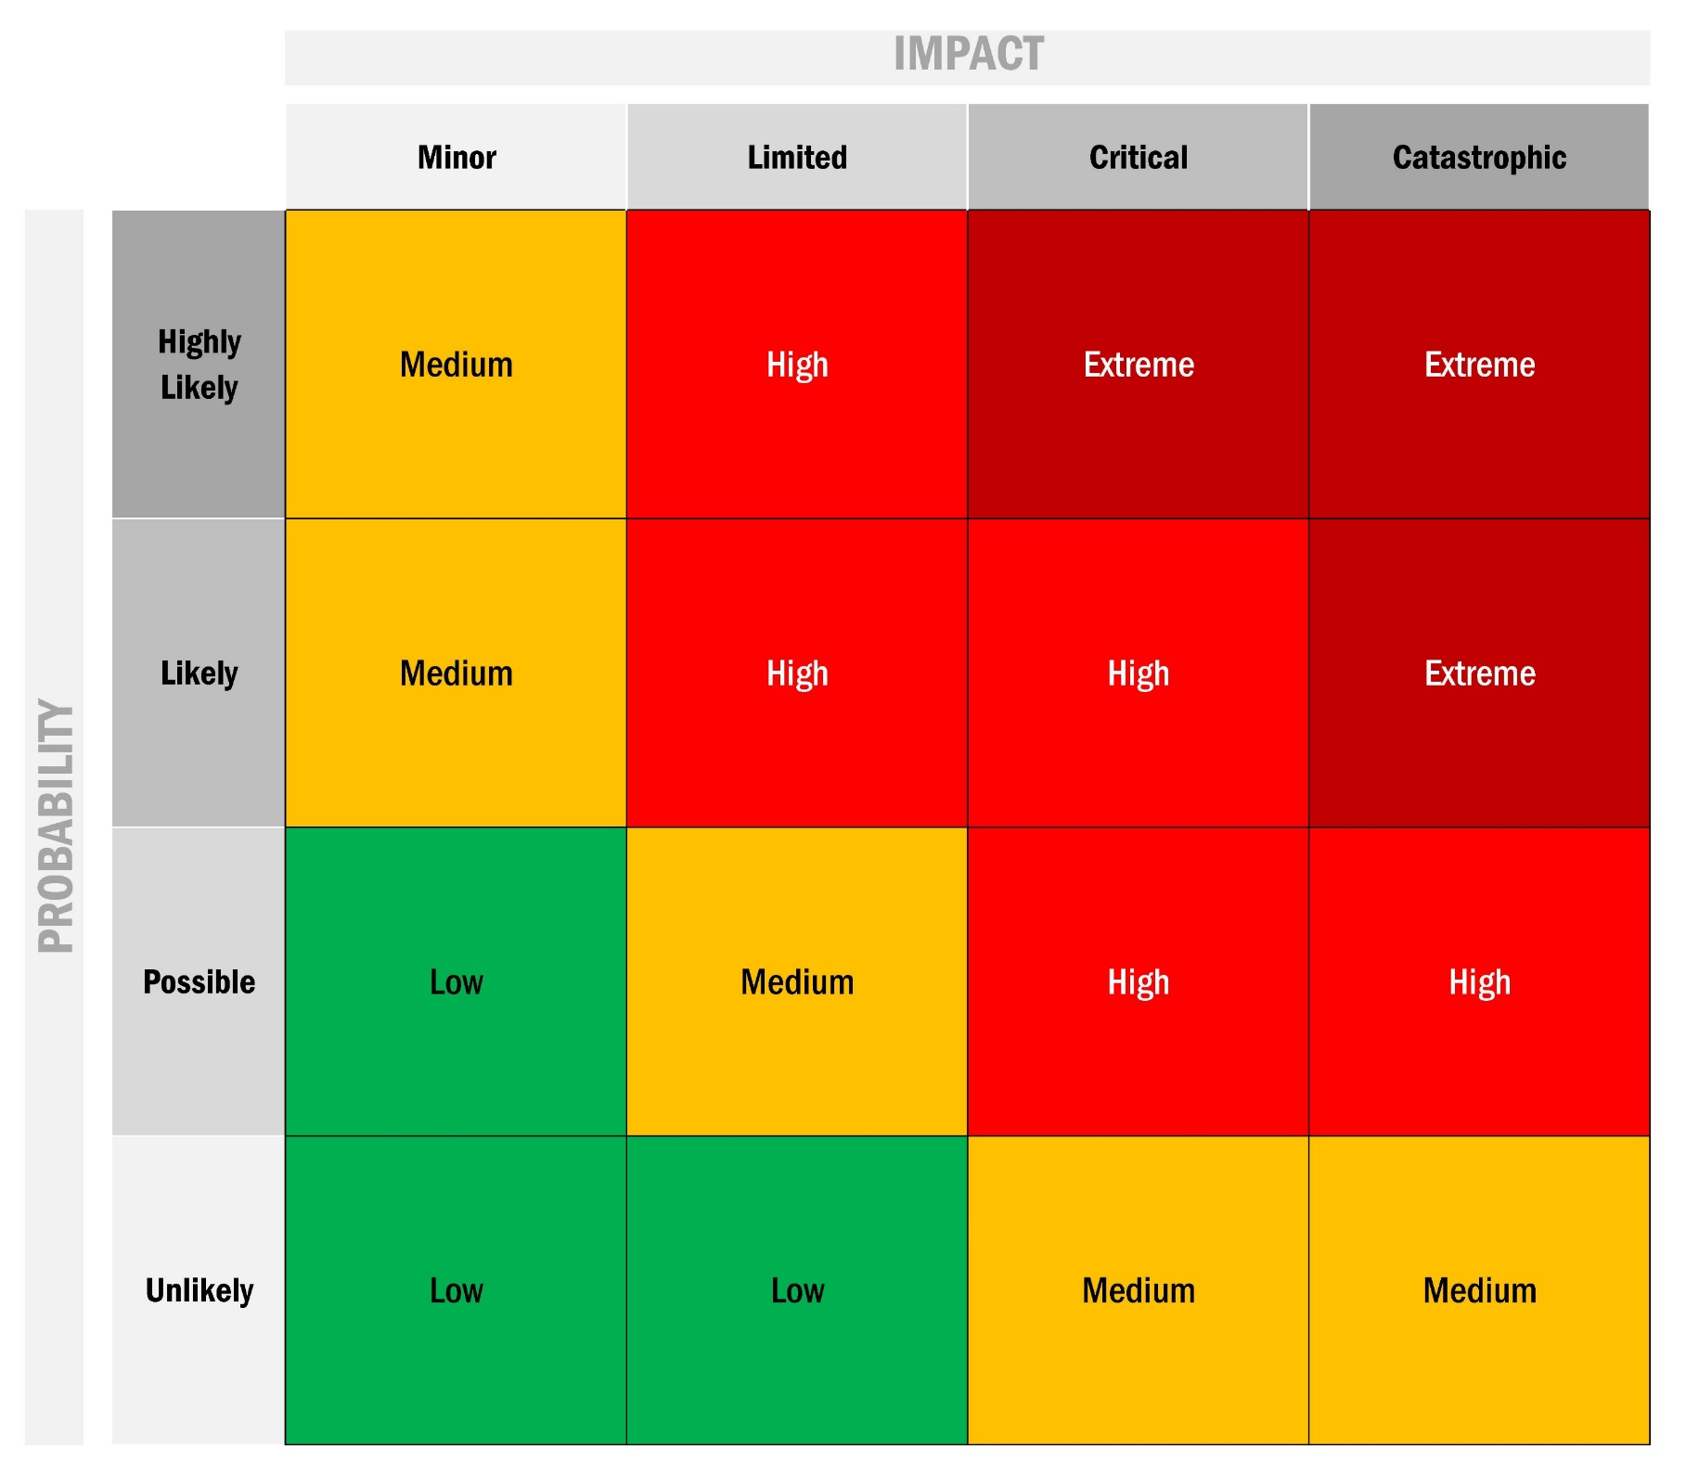
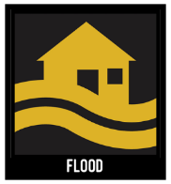
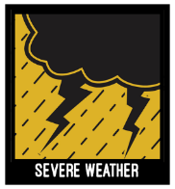
Wildfire
A wildfire is any uncontrolled fire occurring on undeveloped land that requires fire suppression. Wildfires can be ignited by lightning or by human activity such as smoking, campfires, equipment use, and arson. The 2018 California State Hazard Mitigation Plan provides the following definition of wildfires:
any free-burning vegetative fire that initiates from an unplanned ignition, whether natural (e.g., lightning) or human-caused (e.g., powerlines, mechanical equipment, escaped prescribed fires), where the management objective is full suppression.
Wildfires are costly, putting lives and property at risk and compromising rivers and watersheds, open space, timber, range, recreational opportunities, wildlife habitats, endangered species, historic and cultural assets, scenic assets, and local economies. Vulnerability to flooding increases due to the destruction of forest and ground cover within watersheds. The potential for significant damage to life and property increases in areas where development is adjacent to densely vegetated areas, known as wildland urban interface (WUI) areas.
While some fires are allowed to burn naturally in order to maintain or restore the health of forest lands, out of control wildfires need to be prevented through cooperative, community, and land management planning.
Earthquake
Earthquake is the sudden shaking of the ground caused by the passage of seismic waves through Earth’s rocks. Seismic waves are produced when some form of energy stored in Earth’s crust is suddenly released, usually when masses of rock straining against one another suddenly fracture and “slip.” Earthquakes associated with this type of energy release are called tectonic earthquakes. The energy also can be released by elastic strain, gravity, chemical reactions, or even the motion of massive bodies. Earthquakes occur most often along geologic faults, narrow zones where rock masses move in relation to one another.
Earthquakes have different properties depending on the type of fault that causes them. The usual fault model has a “strike” (that is, the direction from north taken by a horizontal line in the fault plane) and a “dip” (the angle from the horizontal shown by the steepest slope in the fault). The lower wall of an inclined fault is called the footwall. Lying over the footwall is the hanging wall. When rock masses slip past each other parallel to the strike, the movement is known as strike-slip faulting. Movement parallel to the dip is called dip-slip faulting. In dip-slip faults, if the hanging-wall block moves downward relative to the footwall block, it is called “normal” faulting; the opposite motion, with the hanging wall moving upward relative to the footwall, produces reverse or thrust faulting.
As a fault rupture progresses along or up the fault, rock masses are flung in opposite directions and thus spring back to a position where there is less strain.
Liquefaction
Liquefaction is a phenomenon in which the strength and stiffness of a soil is reduced by earthquake shaking or other rapid loading. Liquefaction and related phenomena have been responsible for tremendous amounts of damage in historical earthquakes around the world. Soil liquefaction occurs when material that is ordinarily a solid behaves like a liquid. Saturated or partially saturated soil substantially loses strength and stiffness in response to an applied stress such as shaking during an earthquake or other sudden change in stress condition. The phenomenon is most often observed in saturated, loose, low-density, or uncompacted, sandy soils. Loose sand tends to compress when a load is applied. Dense sands, by contrast, tend to expand in volume or 'dilate'. If the soil is saturated by water, which often occurs when soil is below the water table or sea level, then water fills the pore spaces between soil grains.

Flood
Flooding is one of the three primary hazards in California, along with earthquake and wildfire, and statewide represents the second most destructive source of hazard, vulnerability, and risk. (Cal OES, 2018, 375) Flooding a priority hazard for Napa County as well.
In Napa County, a flood occurs when the existing channel of a stream, river, canyon, or other water course cannot contain excess runoff from rainfall or snowmelt, resulting in overflow on to adjacent lands. Flooding may also occur due to high tides and wind.
Connections between a river and its floodplain are most apparent during and after major flood events. A floodplain is the area adjacent to a river, creek or lake that becomes inundated during a flood. Floodplains may be broad, as when a river crosses an extensive flat landscape, or narrow, as when a river is confined in a canyon. These areas form a complex physical and biological system that supports a variety of natural resources and provides natural flood and erosion control. When a river is separated from its floodplain with levees and other flood control facilities, its natural, built-in benefits can be lost, altered, or significantly reduced.
Flood reduction, prevention, and mitigation are a major challenge to Napa County residents and floodplain managers alike. Napa County is almost entirely contained within the Napa River Watershed. Many areas of Napa County are at risk of flooding, especially low-lying properties near the Napa River and its feeder streams, as this section explores in further depth. De-energization
Severe Weather
Severe weather refers to any dangerous meteorological phenomena with the potential to cause damage, serious social disruption, or loss of human life. It includes thunderstorms, downbursts, tornadoes, waterspouts, snowstorms, ice storms, and dust storms.
Severe weather events can be categorized into two groups: those that form over wide geographic areas are classified as general severe weather; those with a more limited geographic area are classified as localized severe weather. Severe weather, technically, is not the same as extreme weather, which refers to unusual weather events at the extremes of the historical distribution for a given area.
De-energization
The risk of wildfire increases when several factors combine—these include high temperatures, high sustained and peak winds, as well as critically low humidity. During these conditions, electrical transmission and distribution lines may ignite fires if they are downed by winds and/or trees. To reduce the chance of accidental fire ignition in certain areas, Pacific Gas & Electric (PG&E) has implemented a practice, known as the Public Safety Power Shutoff (PSPS) Program, across its service areas in California of de-energizing electrical grids or blocks of an area(s) in advance of or during periods of heightened risk conditions.
De-energization of electrical systems in affected areas may pose a life-safety risk to residents and impact other infrastructure systems. De-energization may also impact the capabilities of local agencies to respond to wildfire due to loss of alert & warning and public information communications systems, including internet and cellular towers’ inability to monitor or maintain water supplies, and a loss of traffic control systems that could support evacuation.
Red Flag warning conditions are occurring with greater frequency in recent years. Napa County experienced five Red Flag Warnings totaling 11 days in 2019 and 10 Red Flag Warnings in 2018 totaling 23 days. Since the introduction of the PSPS program in 2017, Napa County has experienced four PSPS events in the past two years. Prior to 2019, from 2008-2018 Napa County experienced an average of 4.73 Red Flag Warnings per year.
Climate Change
Climate change refers to any distinct change in measures of climate lasting for a long period of time, more specifically major changes in temperature, rainfall, snow, or wind patterns. Climate change may be limited to a specific region or may occur across the whole Earth. Climate change may result from:
- Natural factors, such as changes in the Sun’s energy or slow changes in the Earth’s orbit around the Sun.
- Natural processes within the climate system, such as changes in ocean circulation, or
- Human activities that change the atmosphere’s make-up, and the land surface, such as burning fossil fuels, cutting down forests, planting trees, or building developments in cities and suburbs.
The effects of climate change are varied and include warmer and more varied weather patterns, melting ice caps, and poor air quality, for example. As a result, climate change will likely worsen a number of natural hazards including wildfires, floods, drought, severe weather, and levee failure. Sea level rise, a direct result of climate change and related to flooding, affects communities in the San Francisco Bay Area. Sea level rise has the potential to inundate homes, businesses, and infrastructure located near the shorelines, as well as cause erosion of coastal lands over time.
The 2018 California State Hazard Mitigation Plan states that California is already experiencing the impacts of climate change, including prolonged drought, increased coastal flooding and erosion, and tree mortality. The state has also seen increased average temperatures, more extreme heat days, fewer cold nights, a lengthening of the growing season, shifts in the water cycle with less winter precipitation falling as snow, and both snowmelt and rainwater running off sooner in the year. The intensity of extreme weather events is also increasing. Extreme weather events and resulting hazards, such as heat waves, wildfires, droughts, and floods are already being experienced. (CalOES, 2018)
Slope Failure
Landslides, mudflow, debris flow, and rockfall, collectively known as slope failure, may cause damage across the County. They rarely present a threat to human life, but most often result in a disruption of everyday services, including emergency response capabilities. Landslides can block transportation routes, dam creeks and drainages, and contaminate water supplies. When these hazards affect transportation routes, they are frequently expensive to clean-up and can have significant economic impacts to the County
Dam Failure
Dam failures in the United States typically occur in one of four ways:
- Overtopping of the primary dam structure, which accounts for 34 percent of all dam failures, can occur due to inadequate spillway design, settlement of the dam crest, blockage of spillways, and other factors.
- Foundation defects due to differential settlement, slides, slope instability, uplift pressures, and foundation seepage can also cause dam failure. These account for 30 percent of all dam failures.
- Failure due to piping and seepage accounts for 20 percent of all failures. These are caused by internal erosion due to piping and seepage, erosion along hydraulic structures such as spillways, erosion due to animal burrows, and cracks in the dam structure.
- Failure due to problems with conduits and valves, typically caused by the piping of embankment material into conduits through joints or cracks, constitutes 10 percent of all failures.
Many dam failures in the United States have been secondary results of other disasters, such as earthquakes, landslides, extreme storms, massive snowmelt, equipment malfunction, structural damage, foundation failures, and sabotage. Poor construction, lack of maintenance and repair, and deficient operational procedures are preventable or correctable by a program of regular inspections. Terrorism and vandalism are serious concerns that all operators of public facilities must plan for; these threats are under continuous review by public safety agencies.
Pandemic Disease .
The U.S. Center for Disease Control defines an outbreak as the occurrence of more cases of disease than normally expected within a specific place or group of people over a given period of time. rapidly and affects many an epidemic is a localized outbreak that spreads people or animals in a community. A is an epidemic that occurs worldwide or over a very large area and affects a large number of people or animals. The following are the most common types of pandemic diseases in the planning area:
Influenzas – The flu can cause mild to severe illness, and at times can lead to death. Anyone can get sick with the flu, but some people are at a higher risk of flu related complications if they get sick. This includes older and younger people and people with certain chronic medical conditions.
West Nile Virus – West Nile virus (WNV) is a mosquito East, and more recently borne disease that is common in Africa, west Asia, the Middle y, North America. Human infection with WNV may result in serious illness. Experts believe WNV is established as a seasonal epidemic in North America that flares up in the summer and continues into the fall.
Hepatitis C –Hepatitis C is a liver disease caused by the Hepatitis C virus (HCV), which is found in the blood of persons who have this disease. HCV is spread by contact with the blood of an infected person.
Lyme Disease – Lyme disease is an infectious disease caused by a bacterium known as a spirochete. People get Lyme disease when a tick infected with the Lyme disease bacterium attaches and feeds on them. Lyme disease was first recognized in the northeastern United States in the 1970s. Lyme disease has been reported from many areas of the country, including California.
Measles – The measles is a childhood infection caused by a virus. Once quite common, measles can now almost always be prevented with a vaccine. Also called rubeola, measles can be serious and even fatal for small children. While death rates have been falling worldwide as more children receive the measles vaccine, the disease still kills more than 100,000 people a year, most under the age of 5.
As a result of high vaccination rates in general, measles hasn't been widespread in the United States for more than a decade. The United States averaged about 60 cases of measles a year from 2000 to 2010, but the average number of cases jumped to 205 a year in recent years. Most of these cases originate outside the country and occurred in people who were unvaccinated or who did not know whether or not they had been vaccinated.
Rabies – Rabies is a viral infection transmitted in the saliva of infected mammals. Common modes of rabies virus transmissions are through bites and contact with saliva of an infected host. Other various routes of transmission include contamination of mucous membranes, aerosol transmission, and corneal transplantations. Any penetration of the skin by teeth regardless of location, represents a potential risk of rabies transmission. The rabies virus infects the central nervous system, causing encephalopathy and ultimately death.

Agricultural Disasters
California agriculture and forests are at risk from pests and diseases that, under certain conditions, can cause severe economic, environmental, or physical harm. Agricultural disasters could also occur due to severe weather such as severe heat and freeze events.
Agriculture pests and diseases can result in economic and human health disasters. For example, insect pest hazards can have a major economic impact on farmers, farm workers, packers, and shippers of agricultural products. They can also cause significant increases in food prices for consumers due to shortages. In addition, insect pests and diseases such as bark beetles, Sudden Oak Death, and Pitch Canker in trees can destroy large expanses of forest and woodland, increasing the fuel load and contributing to greater fire risk. (CalOES, 2018)
Specifically, The Napa County economy is dependent upon a strong agricultural industry that provides the impetus for food production, jobs, and tourism. The wine, nursery, farm, and tourism industries are integral parts of our diverse economic landscape. Each year the Napa County Agricultural Commission releases a crop report. The crop report value for 2018 was over one billion dollars at $1,038,600,100, an increase of $287,767,700 when compared to 2017. This increase in gross value was primarily due to a 29.6% rise in wine grape production and a 6.7% in average price paid for all Napa County wine grapes varieties compared to the previous year. The total value of all agricultural production was $1,043,192,400. The figure below compares the top six gross crop production values.
Visit Napa Valley strategically manages tourism. On an ongoing basis they track visitor demographics, spending, length of stay and economic contributions to the community to show the true value of tourism. 2018 research show:
- A total of 3.85 million Napa Valley visitors.
- Tourism industry generated $85.1 million in tax relief to residents, an increase of 5.8 percent from 2016.
- The tourism industry generated $2.23 billion in total visitor spending inside Napa County.
- Almost 70 percent is generated from overnight hotel guests, who spend an average of $446 in Napa County per guest, per day.
- Direct visitor spending within the county increased 15.9 percent since 2016, outpacing visitor growth of 8.9 percent in the same time period.
- The tourism industry remains the second largest employer in Napa County (after the wine industry), supporting the livelihood of an estimated 15,872 people in the community, with a combined payroll of $492 million.
- Overnight visitation grew 13.7 percent from 2016 (1.2 million), outpacing day trip growth at 5.3 percent (2.4 million).

Drought
Drought cycles occur every 7‐11 years. During periods of drought, emergency response measures will consist of land use planning practices consistent with water conservation goals and various water conservation measures.

Planning Assumptions
Certain assumptions were established during the development of this plan. These assumptions translate into basic principles associated with conducting emergency management operations in preparation for, response to and recovery from major emergencies.
- Emergency response is best coordinated at the lowest level of government involved in the emergency.
- Emergency management activities are accomplished using SEMS and NIMS
- Local authorities maintain operational control and responsibility for emergency management activities within their jurisdiction unless otherwise superseded by statute or agreement.
- Mutual Aid is requested when needed and provided as available.
- Mitigation activities conducted prior to the occurrence of a disaster result in a potential reduction in loss of life, injuries, and damage.
- Supporting plans and procedures are updated and maintained by responsible parties.

Whole Community Approach
The whole community concept is a process by which residents, emergency management representatives, organizational and community leaders, and government officials can understand and assess the needs of their respective communities and determine the best ways to organize and strengthen their resources, capacities, and interests. Engaging in whole community emergency management planning builds a more effective path to societal security and resilience.
In keeping with the whole community approach, this plan was developed with the guidance and active involvement of representatives from County departments/agencies, City departments, special districts, law enforcement, fire services, emergency management, Napa Valley COAD, Access and Functional Needs communities, tribal communities, business and industry, and various other public and private stakeholders. Each of these stakeholders provided data in alignment with the planning process through one-on-one interviews, participation in planning meetings, formal reviews, and approval and implementation processes. The effectiveness of emergency response is largely predicated on the preparedness and resiliency of the collective community.
Community resiliency consists of three key factors:
- The ability of first responder agencies (e.g. fire, law, emergency medical services) to divert from their day-to-day operations to the emergency effectively and efficiently.
- The strength and inclusivity of the emergency management system and organizations within the region, to include the Emergency Operations Center (EOC), mass notification systems, emergency public information systems, etc.
- The civil preparedness of the region’s citizens, businesses, and community organizations.
Constantly enhancing all three of these components focuses the region on improving its resiliency.

Concept of Operations
This section explains in broad terms, leadership intent with regard to emergency response operations. The Concept of Operations describes how the emergency response organization accomplishes its mission. It includes roles and responsibilities, the organizational element of the overall emergency management program, a brief discussion of the EOC activation levels, and a description of control, direction, and intra- and interagency coordination.
Local governments have the primary responsibility for preparedness and response activities within their jurisdiction. When an emergency exceeds the local government’s capability to respond, assistance is requested from other local jurisdictions, from the Operational Area, Region, State and Federal governments, as needed. In any case, incident command and response operations remain with the local jurisdiction. In accordance with state and federal laws Napa County has officially adopted and integrated the following emergency management, response, and coordination systems:
- Standardized Emergency Management System (SEMS)
- National Incident Management System (NIMS)
Together, these operational systems outline how critical incidents, emergencies, and disasters will be coordinated in the field, at the local level, and up through the county, region, state, and federal levels. The Napa County EOP complies with Federal guidance to use NIMS and State guidance to use SEMS. An overview of each system is included below.
Standardized Emergency Management System (SEMS)
The Standardized Emergency Management System (SEMS) is the cornerstone of California’s emergency response system and the fundamental structure for the response phase of emergency management across the state, in Napa County and all its political subdivisions. SEMS is required by the California Emergency Services Act (ESA) for managing multiagency and multijurisdictional responses to emergencies in California. The system unifies all elements of California’s emergency management community into a single integrated system and standardizes key elements. SEMS incorporates the use of the Incident Command System (ICS), California Disaster and Civil Defense Master Mutual Aid Agreement (MMAA), the Operational Area (OA) concept and multiagency or inter-agency coordination. State agencies are required to use SEMS and local government entities must use SEMS in order to be eligible for any reimbursement of response-related costs under the state’s disaster assistance programs.
There are five SEMS organizational levels, as outlined below:
Field – The Field Level is where emergency response personnel and resources, under the command of responsible officials, carry out tactical decisions and activities in direct response to an incident of threat.
Local Government – The Local Government Level includes cities, counties, and special districts. Local governments manage and coordinate the overall emergency response and recovery activities within their jurisdiction. Local governments are required to use SEMS when their Emergency Operations Center (EOC) is activated or a local emergency is declared or proclaimed in order to be eligible for state reimbursement of response-related costs. Local governments within Napa OA include City of American Canyon, City of Napa, City of Calistoga, Town of Yountville, and City of St. Helena.
Operational Area (OA) – An OA is the intermediate level of the state's emergency management organization, which encompasses a county’s boundaries, and all political subdivisions located within that county, including special districts. The OA facilitates and/or coordinates information, resources, and decisions regarding priorities among local governments within the OA. The OA serves as the coordination and communication link between the Local Government Level and Regional Level.
Region – The Regional Level manages and coordinates information and resources among OAs within the mutual aid region and also between the OA and the State Level. The Regional Level also coordinates overall state agency support for emergency response activities within the region. Napa County is part of the Cal OES Coastal Region.
State – The State Level of SEMS prioritizes tasks and coordinates state resources in response to the requests from the Regional Level and coordinates mutual aid among the mutual aid regions and between the Regional Level and State Level. The State Level also serves as the coordination and communication link between the state and the federal emergency response system. The State Level requests assistance from other state governments through the Emergency Management Assistance Compact (EMAC) and similar interstate compacts/agreements and coordinates with the Federal Emergency Management Agency (FEMA) when federal assistance is requested. The State Level operates out of the State Operations Center (SOC).
At the Federal Level, the National Response Framework (NRF) identifies the methods and means for federal resources to provide support to the state and local government. Federal resources would be accessed via the SEMS process through the mutual aid region and State Operations Center.

SEMS Functions
SEMS requires that every emergency response involving multiple jurisdictions or multiple agencies include the five functions identified in SEMS Functions chart below. These functions must be applied at each level of the SEMS organization. Napa County’s EOC is organized following SEMS and the ICS structure, providing EOC staff with a standardized operational structure and common terminology based on five major functional areas: Management/Command, Operations, Planning, Logistics, and Finance/Administration. Those functions are further described in the below section on EOC Structure.
PRIMARY SEMS FUNCTION | LOCAL GOVERNMENT LEVEL | STAFFING RESOURCES
Command/  Management | Command is responsible for the directing, ordering, and/or controlling of resources. | Chief Administrative Officers, City Managers, Chief Executive Officers, and their respective support staffs, to include Public Information or Public Affairs.
Operations | The coordinated tactical response of all field operations in accordance with the Incident Action Plan. | Key department managers and supervisors within public safety agencies, public works, parks, and other entities that possess resources and personnel that can be utilized in the response. The configuration of Operations may vary in other types of organizations such as special districts and schools.
Planning/Intelligence | The collection, evaluation, documentation, and use of information related to the incident. | Community Development, Planning Departments, together with representatives from public safety and public works staffs.
Logistics | Providing facilities, services, personnel, equipment, and materials in support of the incident. | Departments of General Services, Public Works and utilities are often used to staff Logistics. Other departments such as telecommunications may also assist with this function.
Finance/Administration | Financial and cost analysis  and administrative aspects not  handled by the other  functions. | Finance, Budgets, Purchasing, Risk Management, and other similar departments are appropriate sources of staffing for this function.

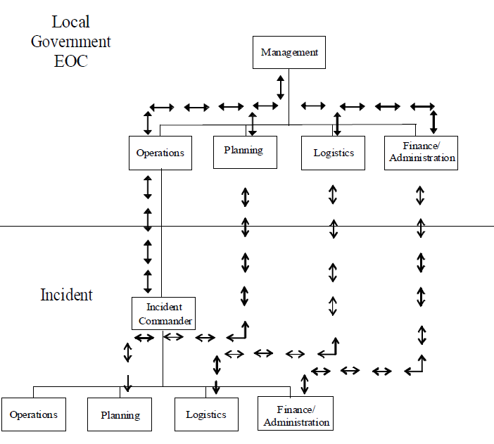
Napa County’s emergency response organization is informed by the following SEMS components:
- Management by Objectives -The Management by Objectives (MBO) feature of ICS, as applied to SEMS, means that each SEMS Level establishes for a given Operational Period, measurable and attainable objectives to be achieved. An objective is an aim or end of an action to be performed. Each objective may have one or more strategies and performance actions needed to achieve the objective.
- Operational Period -The Operational Period is the length of time set by command at the Field Response Level and by management at other levels to achieve a given set of objectives. The period may vary in length from a few hours to days and will be determined by the situation.
- Action Plans - Action planning should be used at all SEMS Levels. There are two types of action plans in SEMS: Incident Action Plans and EOC Action Plans. Incident Action Plans (IAP) are used at the Field Response Level. The IAP can be either written or verbal although for documentation purposes the written IAP is preferable. The IAP contains objectives reflecting the overall incident strategy, specific tactical actions and supporting information for the next Operational Period. Incident Action Plans are an essential and required element in achieving objectives under ICS. EOC Action Plans are crafted at Local Government, Operational Area, Region, and State EOC Levels. The use of EOC Action Plans provides designated personnel with knowledge of the objectives to be achieved and the steps required for achievement. EOC Action Plans not only provide direction, but also serve to provide a basis for measuring achievement of objectives and overall system performance. Action Plans can be extremely effective tools during all phases of a disaster.
- Organizational Flexibility – A Modular Organization - The intent of this SEMS feature is that at each SEMS Level, only those functional elements that are required to meet current objectives need to be activated. All elements of the organization can be arranged in various ways within or under the five SEMS essential functions. The functions of any non-activated element are the responsibility of the next highest element in the organization. Each activated element must have a person in charge; however, one supervisor may be in charge of more than one functional element.
- Organizational Unity and Hierarchy of Command - Organizational unity means that every individual within an organization has a designated supervisor. Hierarchy of command/ management means that all functional elements within each activated SEMS Level are linked together to form a single overall organization with appropriate span of control limits.
- Span of Control - Maintaining a reasonable span of control is the responsibility of every supervisor at all SEMS Levels. The optimum span of control is three to five, meaning that one supervisor has direct supervisory authority over five positions or resources. The recommended span of control for supervisory personnel at the Field Response Level and all EOC Levels should be in the one-to-three to one-to-seven ratio. A larger span of control may be acceptable when the supervised positions or resources are all performing a similar activity.
- Personnel Accountability - An important feature to all SEMS Levels is personnel accountability. This is accomplished through the Organizational Unity and Hierarchy of Command or Management features, along with the use of check-in forms, position logs and various status forms. The intent is to ensure that there are proper safeguards in place so all personnel at any SEMS Level can be accounted for at any time.
- Common Terminology - In SEMS, common terminology is applied to functional elements, position titles, facility designations, and resources. The purpose of having common terminology is to rapidly enable multi-agency, multi-jurisdiction organizations and resources to work together effectively. This will vary from level to level in terms of directing, controlling, coordinating, and resource inventorying. Procedures for effective resources management must be geared to the function and the level at which the function is performed.
- Integrated Communications - This feature of SEMS relates to hardware systems, planning for system selection and linking, and the procedures and processes for transferring information. At the Field Response Level, integrated communications are used on any emergency. At and between all SEMS Levels, there must be a dedicated effort to ensure that communications systems, planning, and information flow are accomplished in an effective manner. The specifics of how this is accomplished at EOC Levels may be different than at the Field Response Level.
National Incident Management System (NIMS)
NIMS guides all levels of government, nongovernmental organizations (NGO), and the private sector to work together to prevent, protect against, mitigate, respond to, and recover from incidents. NIMS provides stakeholders across the whole community with the shared vocabulary, systems, and processes to successfully deliver the capabilities described in the National Preparedness System. NIMS defines operational systems, including the Incident Command System (ICS), Emergency Operations Center (EOC) structures, and Multiagency Coordination Groups (MAC Groups) that guide how personnel work together during incidents. NIMS applies to all incidents, regardless of size, complexity, or scope, and planned events (e.g., sporting events).

Emergency Operations Center (EOC)
The Napa County EOC is the central coordination point for multi-agency emergency management coordination. The purpose of a multi-agency coordination point is to provide a location to collect and disseminate information, provide a common operating picture of operational area response activities, and facilitate actions necessary to protect residents and property of Napa County during an event. Napa County has developed an EOC Plan as an annex to this EOP, which includes more specific operational guidance and position description for EOC roles.
The EOC exchanges information with governmental and nongovernmental agencies in order to maintain a comprehensive situational analysis. The EOC provides space and facilities for the centralized coordination of emergency functions (e.g., emergency operations, communications, damage assessment, public information). It is staffed with specially trained personnel and is equipped with a variety of systems and tools that aid in data collection and sharing, resource allocation, and other critical functions.
The Napa County EOC is located at 1535 Airport Blvd, Napa, CA 94558 on the west side of the second floor of the Napa County Sheriff’s Office. The facility has 36 desktop workstations. If that site is unusable, the alternate EOC site at Napa Valley College at 2751 Napa Valley Corporate Drive will be used.

EOC Primary Functions
The following are primary roles and responsibilities of the EOC:
- Serve as a central information sharing center
- Collect, gather, and analyze data
- Maintain a countywide common operating picture of response activities
- Prepare OA-wide situation reports
- Coordinate/communicate Policy Group priorities
- Implement event management-by-objective
  - Reconcile competing objectives
  - Coordinate resource allocation priorities
- Maintain communication with DOCs and city/special district EOCs
  - Ensure that departments are aware of current incident objectives and make collaborative decisions
  - Maintain a common level of situational awareness throughout the operational area
- Communicate and coordinate with the REOC
- Serve as a coordination and communication center for all County stakeholders, including the private sector and non-governmental organizations (NGOs), such as community hospitals, clinics, and ambulance providers

Activation
This section identifies when to activate the EOC and the different types of activation. The State of California Emergency Plan identifies three levels of EOC activation used to categorize a possible response. These same levels are used by Napa County and are common to all functional annexes:
Activation Level | Conditions / Definition
Full | - Large-scale disaster  - For a full activation, the EOC is activated, and all or most of the positions are filled. A full activation occurs for the most significant events involving the use of the full scope of County resources, with a potential need for additional assistance
Partial | - Small to moderate disaster, pre-planned event, or beginning or late stages of a larger disaster  - For a partial activation, the EOC is activated but only some of the positions are filled. Staffing needs for partial activations vary depending on the scope of the event and must be adaptable to changing conditions.
Monitoring/Normal Operations | - Duty Officer Status  - The County is in steady-state operations and the EOC is not activated. Napa County OES maintains situational awareness

When activating the EOC, the responsible official should consider the following as part of the process of activation:
- Determine the scope of the incident or event
- Determine the appropriate level of activation
- Notify/recall EOC staff for activation
- Open the EOC and prepare the facility to host operations
The Napa County EOC can be activated or deactivated by the following officials:
- County Executive Officer as Director of Emergency Services, or their designee
- Emergency Services Manager or their designee
- Sheriff or their designee
- Fire Chief or their designee
EOC Structure
The Napa County EOC is organized following SEMS and the ICS structure, providing EOC staff with a standardized operational structure and common terminology based on five major functional areas—Management, Planning, Operations, Logistics, and Finance and Administration. Collaboration and development of consensus within the EOC occur under ICS through use of a structured method for developing priorities and objectives called the EOC Action Planning process. All EOC sections provide input to the Planning Section, the Policy Group, and the EOC Management Team for the development of EOC priorities. These priorities serve as guidance for the allocation of resources and enable the EOC to sufficiently coordinate requests for support from local government and the field. The EOC Plan Annex describes the EOC structure and activities in more detail. The EOC Position Action Guide Annex describes EOC roles and responsibilities in detail.
The five major functional areas of the EOC are:
Command/Management:
Command is responsible for the directing, ordering, and/or controlling of resources at the field response level. Management is responsible for overall emergency policy and coordination at the SEMS EOC levels. Command and
Management are further discussed below:
- Command: A key concept in all emergency planning is to establish command and tactical control at the lowest level that can perform that role effectively in the organization. In the Incident Command System (ICS), the Incident Commander (IC), with appropriate policy direction and authority from the responding agency, sets the objectives to be accomplished and approves the strategy and tactics to be used to meet those objectives. The IC must respond to higher authority. Depending upon the incident’s size and scope, the higher authority could be the next ranking level in the organization up to the agency or department executive.
- Management: The EOC serves as a central location from which multiple agencies or organizations coordinate information collection and evaluation, priority setting and resource management. Within the EOC, the Management function:
  - Facilitates multiagency coordination and executive decision making in support of the incident response
  - Implements the policies established by the governing bodies
  - Facilitates the activities of the Multiagency (MAC) Group
Operations:
The Operations Section supports all tactical emergency response assets, regardless of agency affiliation or type. The Operations Section orchestrates strategic support to all emergency response operations and requests additional resources, as needed. The Operations Section implements the EOC Incident Action Plan (IAP) and facilitates the direction of and makes changes based on the needs of the emergency. The Operations Section staff must evaluate the potential economic, social, and environmental impacts of the disaster on its citizens, while managing response to the conditions within the County.
Logistics:
The Logistics Section ensures that all other sections are supported for the duration of the incident. The Logistics Section's primary responsibility is to ensure the acquisition, transportation, and mobilization of resources are available to support the response effort at the disaster sites, public shelters, EOCs, etc. This Section provides all necessary personnel, supplies and equipment procurement support.
Methods for obtaining and using facilities, equipment, supplies, services, and other resources to support emergency response at all operational sites during emergency conditions, will be the same as those used during normal operations unless authorized by the Director of Emergency Services. The difference is the coordination will be from the EOC.

Planning:
The Planning Section is responsible for the collection, evaluation and dissemination of operational information related to the incident for the preparation and documentation of the IAP. Planning also maintains information on the current and forecasted situation and on the status of resources assigned to the emergency or the EOC. As needed, Unit Coordinators are appointed to collect and analyze data, prepare situation reports, develop action plans, set Geographic Information Systems (GIS) priorities, compile and maintain documentation, conduct advance planning, manage technical specialists and coordinate demobilization.
Finance/Administration:
Finance/Administration Section is responsible for all financial and cost analysis aspects of the emergency and for any administrative aspects not handled by the other functions. As needed, Unit Leaders are appointed to record time for incident or EOC personnel and hired equipment, coordinate procurement activities, process claims and track costs.

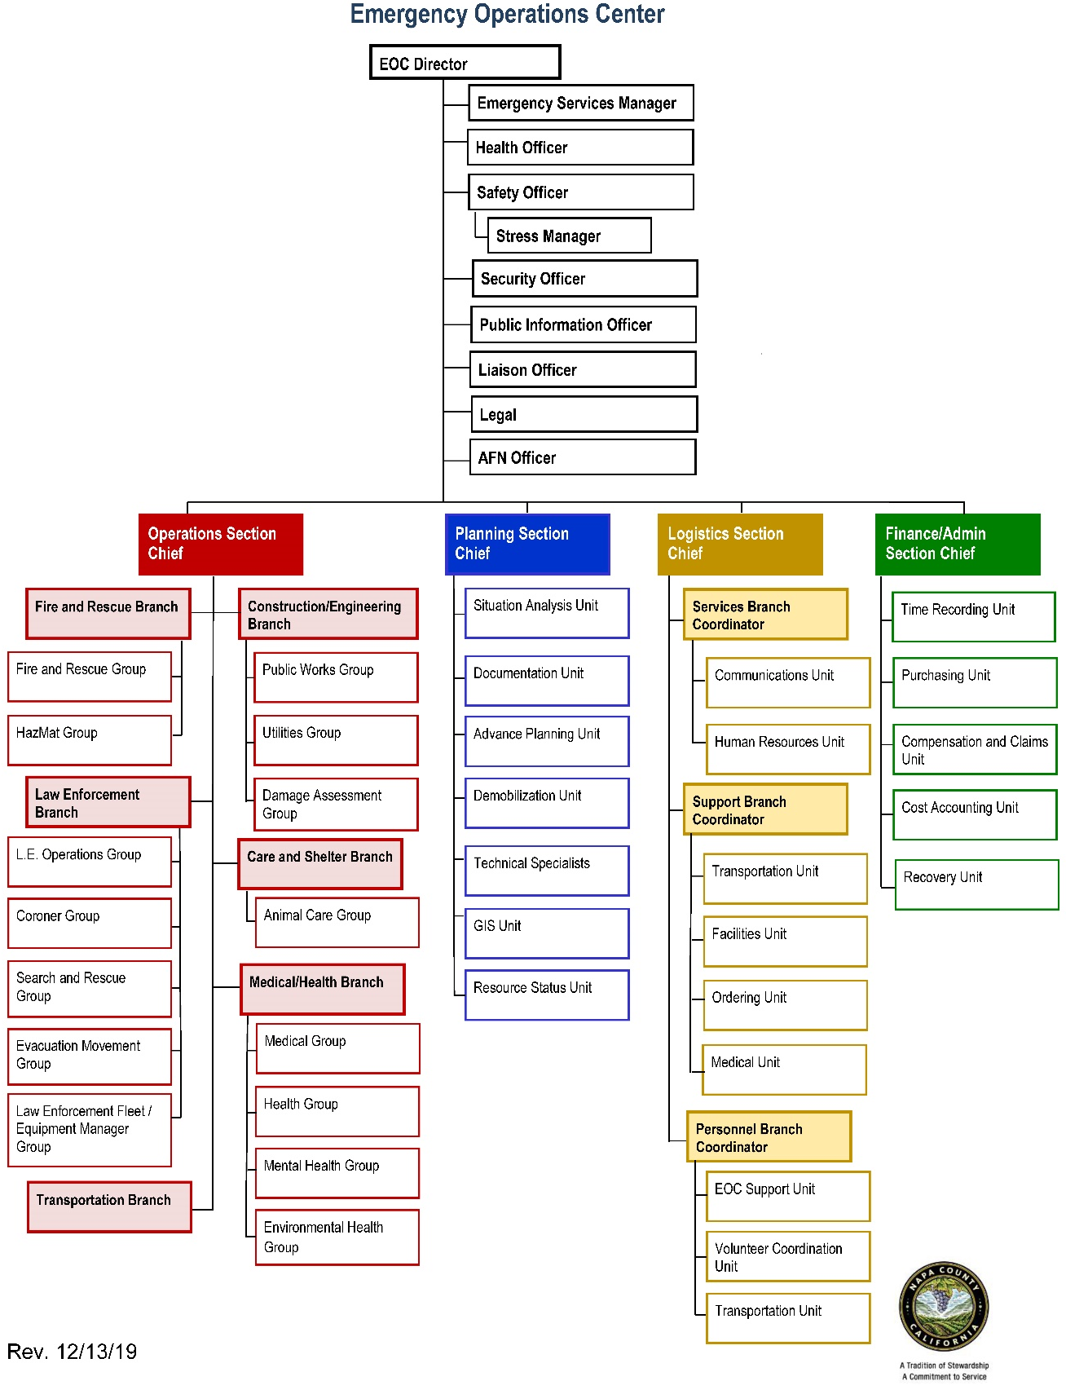

Proclaiming an Emergency
The authority to proclaim a local emergency in Napa County is vested in the Napa County Board of Supervisors, or in its absence, the Director of Emergency Services (County Executive Officer), Sheriff, Emergency Services Manager, or Public Health Officer, or a designated alternate. A proclamation of a Local Emergency is invalid after seven days, unless ratified by the governing body (Board of Supervisors). In the event that the governing body ratifies the proclamation, and the proclamation extends beyond seven days, the governing body must review the need to continue the proclamation at least every fourteen days until the Local Emergency is terminated. In any case, the governing body must proclaim the termination of the Local Emergency as soon as conditions warrant.
When Napa County proclaims a Local Emergency, cities and political subdivisions within the operational area are covered under the County’s proclamation. According to the California Emergency Services Act, a proclamation of Local Emergency provides the local governing body the authority to:
- Request and receive assistance from local agencies and assistance from the State under the California Disaster Assistance Act (CDAA).
- In the absence of a Presidentially proclaimed State of War Emergency or State of Emergency, recover from the State the cost of extraordinary services incurred in executing mutual aid agreements.
- Provide public employees, disaster service workers, and governing bodies certain legal immunities for emergency actions taken.
- Promulgate orders and regulations necessary to provide for protection of life and property.
- Promulgate orders and regulations imposing curfew.
Additionally, the County defines in municipal code 2.80.060, the following:
- When there is a proclamation of a local emergency or the proclamation of a State of Emergency or State of War Emergency, the director of emergency services is empowered to:
  - To make and issue rules and regulations on matters reasonably related to the protection of life and property as affected by such emergency; provided, however, such rules and regulations must be confirmed at the earliest practicable time by the board of supervisors
  - To obtain vital supplies, equipment and such other properties needed for the protection of life and property, and to obligate the city for the fair value thereof and, if required immediately, to commandeer for public use.
  - To require emergency services of any county officer or employee and, in the event of the proclamation of a state of emergency in the county or the existence of a state of war emergency, to command the aid of as many citizens of this community as he or she deems necessary. Such persons shall be entitled to all privileges, benefits, and immunities as are provided by state law for registered disaster service workers.
  - To requisition necessary personnel or material of any county department or agency.
To execute all of the ordinary powers as county administrator, all of the special powers conferred upon them by this chapter or by resolution or emergency plan adopted by the board of supervisors, as well as all powers conferred by any statute, by any agreement approved by the board of supervisors, and by any other lawful authority.

Notification Process:
- When local governments within the County proclaim a local emergency under their own authorities, they should notify Napa County as the Operational Area (OA) and provide a copy of the local emergency proclamation as soon as possible
- Napa County will notify the Cal OES Coastal Regional and provide a copy of the proclamation as soon as possible
- Coastal Region will notify the OES Director and Deputy Directors; and shall be the primary contact between the OES Director, OA, and the local jurisdiction for updates on any requests for assistance
- OES Director will respond in writing to the local government concerning the status of any requests for assistance included within the local proclamation or accompanying letter
It is also important to note that local emergency proclamations and/or Governor’s Proclamations are not prerequisites for mutual aid assistance, Red Cross assistance, the federal Fire Management Assistance Grant Program, or disaster loan programs designated by the Small Business Administration, or the U.S. Department of Agriculture.

Mutual Aid Coordination
Under the terms of California’s Disaster and Civil Defense Master Mutual Aid Agreement, statewide emergency assistance is provided on a voluntary basis from one jurisdiction to another at no cost to the receiving jurisdiction. Mutual aid is intended to ensure that adequate resources, facilities, and other emergency support are provided to jurisdictions whenever their own resources prove to be inadequate to cope with a given situation.
The California Mutual Aid System operates within the framework of the Master Mutual Aid Agreement and under the authority of the California Emergency Services Act. The system is a formal process designed to mobilize resources to and from emergency response agencies, local governments, OAs, regions, and the State with the intent to provide requesting agencies with sufficient resources.
To facilitate mutual aid, mutual aid coordinators are designated at the OA, regional, and State levels. The basic role of a mutual aid coordinator is to receive requests, coordinate the provision of resources from within the coordinator's geographic area of responsibility, and pass on unfilled requests to the next level. Napa County OA mutual aid coordinators (e.g., Law Enforcement, Fire Service and Rescue, Medical Health personnel) will be assigned during an EOC activation. If mutual aid requests do not fall into one of the discipline-specific mutual aid systems, then the requests are handled through the emergency services mutual aid system, managed by emergency management staff at Napa County OES.
The involvement of NGOs, special districts, and private sector organizations with Napa County mutual aid will vary according to the resources that may be made available and the types of resources needed. Some organizations may use internally established mutual aid systems/arrangements in order to acquire needed resources. For example, the American Red Cross will utilize the American Red Cross Disaster Services Human Resources System (DSHR) when a disaster response requires greater resourcing than can be provided from the local chapter.

Deactivation
At a point in time when response activities transition to recovery activities, the use of the EOC to coordinate resource support and information sharing may continue. A Recovery Taskforce or Recovery Operations may continue operations in the EOC until it is determined that situation is stable to reconvene in other facilities. The activity of Recovery activities will continue long after deactivation of the EOC continue for longer period. The Planning Section Chief is responsible for presenting the deactivation recommendation to the EOC Director. The Action Planning Unit is responsible for planning for the transition from response to recovery operations.
When no longer necessary, individual EOC positions should be formally de-activated. Prior to deactivating the EOC, the Liaison Officer should notify all internal and external partners of the decision to deactivate and the date/time of deactivation, while providing instructions for continued coordination outside the EOC. After deactivation, all documentation should be gathered and maintained to support recovery efforts and the after-action review. Additionally, the EOC should be restocked and prepared for future activations.

Information Collection, Analysis, and Distribution
The Emergency Operations Center (EOC) serves as a hub for collecting, analyzing, and disseminating timely, accurate, consistent, and accessible information relating to the incident or event. Establishing a common operating picture and maintaining situational awareness are essential to incident management and are a major role of the EOC.
Information for the public is coordinated across multiple jurisdictions and agencies, including nongovernmental organization and private businesses, and is disseminated through several mechanisms under the control of the County Executive Office.
Information Collection into the EOC
Information will be sent into the EOC from various sources, including county departments, the JIC, activated local government EOCs, field area commanders, private sector partners, and elected officials, and other sources utilizing the CalEOC platform. Calls into the EOC will be screened by the EOC support unit for appropriateness and routed to the appropriate section.

Information dissemination within the EOC
Information communication will take place using various communications tools. Primarily, the EOC provides the structure for face‐to‐face communication and coordination. The EOC Message Form is used for written communications and documentation of key messages. Situation Status Boards (e.g., Monopad, whiteboards and overhead projected information) are kept updated throughout the duration of an EOC activation to provide instant status communication; this information is regularly recorded and documented by the Planning Section.
The EOC is equipped with a wide variety of communications systems in addition to the public dial network (phone and Internet access). The systems provide alternate modes of communications to County departments and support agencies and to a broad range of State and other agencies. In addition to radio-based communications, the EOC has several satellite communication systems that allow connection back into the phone system if local circuits are busy or disrupted. Currently, Napa County maintains alternate systems for emergency communications. Further details regarding Napa County emergency communications systems can be found in the Communications Annex and the Tactical Interoperable Communications Plan.

Information communicated outside of the EOC
The EOC provides the single point of contact for information sharing to agencies and entities within and outside of the Operational Area. Such communications take place via typical systems such as telephone and email; the CalEOC program is used to provide and document key information sharing and resource requests to the Coastal REOC. In cases where the day‐to‐day operating systems are impacted, the State’s Operational Area Satellite Information System (OASIS) will be used to establish the link to the network server, allowing the County to transmit the data to the State. OASIS is a network of over 80 earth stations (terminals) located statewide. The terminals provide broadband internet and telephone access immune to regional failures in the terrestrial network. A number of reports will be used to communicate and document information, including the Preliminary Report, the Situation Summary, the Status Report, and a Flash Report.

Alert and Warning
Alert and warning are the process by which the public, businesses, and other local entities are provided information regarding a (potential) emergency, along with instructions as to appropriate actions. The County uses various mechanisms to disseminate alerts and warnings to the public. Among them are social media, standard media, radio, Alert SCC, Nextdoor.com, print, electronic signs, and the Emergency Alert System. Additional methods are used for to reach those with access and functional needs.
In compliance with SB 833, Napa County is a registered federal Wireless Emergency Alert (WEA) operator and has functional, up-to-date WEA software and annual training for operation of the WEA system.
It is the policy of the Napa OA to immediately notify local communities upon the confirmation of a significant emergency or dangerous situation involving an immediate threat to the health or safety of residents and visitors occurring with the County unless issuing a notification will worsen or compromise efforts to contain the emergency.
In order to fulfill this policy, the Office of the Chief Executive Office will:
- Confirm the existence of a credible emergency event or dangerous situation
- Determine appropriate segments of the Operational Area to notify
- Determine message content and appropriate notification methods to employ
- Initiate notifications systems

Mass Notification Systems
Mass Notification Systems are capable of broadcasting public warnings to large numbers of people through multiple devices, such as landline, mobile and VoIP telephones, electronic mail, text message, outdoor sirens/speakers, and TTY/TDD.
The goal of the County’s mass notification program is to establish and implement systems within the jurisdictional boundaries of Napa County that “alert emergency response personnel and the public to the threat of extraordinary danger and the related efforts that specific hazards may cause.” To help meet this goal, the County may employ multiple mass notification platforms to alert individuals of an emergency.
Napa County has a Mass Notification Plan that exists as an Appendix to this EOP. The purpose of the Mass Notification Plan document plan is to provide guidance on the use and administration of Napa County’s mass notification systems. It establishes processes and policies and assigns roles and responsibilities related to the county’s mass notification program. The plan may be used for a broad range of emergencies, including natural disasters, technological incidents, and national security emergencies.
Please see the Napa County Mass Notification Plan for more information on Alert and Warning.

Organization and Assignment of Responsibilities

Overview of Key Functions
Key functions of the Napa County OES are:
- Coordinate in-County efforts of emergency mitigation, preparedness, response, and recovery
- Coordinate in‐County mutual aid
- Maintain liaison with all local, Regional and Cal OES personnel
- Designate multipurpose staging areas
- When appropriate, request mutual aid from State OES

Department Responsibilities
Napa County OES will submit information and requests for support to the appropriate section at the Regional Emergency Operations Center (REOC). Discipline-specific mutual aid systems including fire, law enforcement, and medical and health have designated Mutual Aid Coordinators within each Operational Area. The designated Operational Area Mutual Aid Coordinators are an integral part of the operational area emergency management organization.
Operational Area Mutual Aid Coordinators may be located at the Operational Area EOC, at their normal work location, or at another location depending on the emergency situation, local communications systems, their normal job responsibility, and the level of Operational Area EOC activation. When the Operational Area EOC is fully activated, all Operational Area Mutual Aid Coordinators should have designated representatives at the EOC to facilitate coordination and information flow.
Coordination of discipline‐specific resources will be accomplished through their respective mutual aid systems. However, it is essential that information and overall priorities be coordinated among Mutual Aid Coordinators and the Operational Area EOC.

Crosswalk of Emergency Functions and Agency Responsibilities
Emergency Operations Responsibilities
Function | Annex(es) | Primary Agency
ESF #1 – Transportation | Annex 7 – Evacuation | Napa Valley Transportation Authority (NVTA)
ESF# #2 – Communications | EOC Plan  EOC Position Action Guide  Napa County Mass Notification Plan | Napa County Executive Office
ESF #3 – Public Works and Engineering | Annex 3 – Dam Failure  Annex 4 – Debris Management | Napa County Public Works, Planning, Building, and Environmental Services
ESF #4 – Firefighting | Annex 17 - Wildfire | Napa County Fire Department
ESF #5 – Information & Planning | EOC Plan  EOC Position Action Guide | Napa County Office of Emergency Services (OES)
ESF #6 – Mass Care | Annex 11 – Mass Care | Napa County Office of Emergency Services (OES)
ESF #7 – Logistics Management & Resource Support | EOC Plan  EOC Position Action Guide | Napa County Executive Office
ESF #8 – Public Health and Medical Services | Annex 13 – Pandemic | Napa County Health & Human Services Agency
ESF #9 – Search and Rescue | Annex 11 – Mass Fatality | Napa County Fire Department
ESF #10 – HAZMAT | Annex 9 - HAZMAT | Napa County Fire Department
ESF #11 – Agriculture and Natural Resources | Annex 2 - Agriculture | Napa County Agricultural Commissioner's Office
ESF #12 – Energy | Annex 13 - PSPS | Napa County Public Works, Planning, Building, and Environmental Services
ESF #13 – Public Safety and Security | Annex 14 – Terrorism | Napa County Sheriff’s Office
ESF #14 – Long-Term Community Recovery | Napa County Long-Term Disaster Recovery Plan | Napa County Office of Emergency Services (OES)
ESF #15 – External Affairs | EOC Plan  EOC Position Action Guide | Napa County Executive Office

Direction, Control, and Coordination
The County Executive Officer or their designee has the power, by county code, to direct staff and civilian responses in the County and to settle questions of authority and responsibility. If necessary, to protect life and property or to preserve public order and safety, the Board of Supervisors or the County Executive Officer may promulgate orders and regulations. These must be in writing and must be given widespread publicity. In a proclaimed emergency, the County Executive Officer, or designee may buy or commandeer supplies and/or equipment and may command the aid of citizens.
Additionally, the Governor has the power to suspend State agency orders, rules, or regulations that may impede emergency responses. Local governments generally do not have this power, except by order of the Governor

Coordination with Field-Level Incident Command Posts
Field-level responders organize according to the Incident Command System (ICS) and coordinate with Dispatch Centers, DOCs and/or the EOC to share information and request support.
Napa County is responsible for coordinating the resources, strategies, and policy for any event in the operational area that exceeds the capacity of field tactical responders. Tactical control remains the responsibility of field Incident Commanders at all times. The County Executive Officer or a designated alternate in their capacity as Director of Emergency Services, will provide direction and control over the coordination of multi‐department and multijurisdictional resources to support the field responders.

Coordination with Cities in the OA (Local level)
The cities of American Canyon, Napa, Calistoga, St. Helena, and the Town of Yountville are incorporated cities in the County of Napa. Each city has an Emergency Management Organization. In Napa County, the emergency management organizations of each incorporated city and Special Districts are responsible for coordination and direction of response and recovery operations within their jurisdictions, while the County emergency management organization will serve in a support role. The County is responsible for coordinating and directing response and recovery operations in the unincorporated areas of the County, with the cities providing support and mutual aid as needed. Incorporated Cities and Special Districts, including school districts and water districts, must:
- Develop and maintain Annexes consistent with Napa County Multi-Jurisdictional EOP and the State EOP
- Maintain liaison with neighboring jurisdictions, County OES and other cities
- Designate Multipurpose Staging Areas for the purpose of providing rally points for incoming mutual aid and staging areas for support and recovery operations

Coordination with Special Districts/Utilities Providers in the OA
When activated, the County EOC coordinates with special districts and utilities through their activated EOCs to share information and request or provide support, as necessary. For some incidents, the County may choose to send a liaison to a special district or utility, or they may send a liaison to the County EOC in order to share information and make decisions more efficiently. Depending on the magnitude of the incident and personnel availability, special district and utility liaisons may need to provide the liaison to the County EOC as a resource in support of the entire Operational Area and its jurisdictions.

Coordination with Voluntary Organizations
The OA works closely with Napa Valley Community Organizations Active in Disasters (COAD) and depending on the magnitude and needs of the incident, invites a COAD liaison to the County EOC. COAD includes non-profits and faith-based organizations that offer their services, with no legal mandate. COAD mobilizes and provides valuable assistance for survivors before, during, and after incidents. These organizations train and plan to effectively to integrate volunteers into the County’s incident response and recovery organization. They are valuable partners having established relationships with the community and they offer expanded.

Napa County (OA-level)
The County functions as the Operational Area and is the focal point for information transfer and support requests by cities and Special Districts within the County. The County’s EOC will coordinate resource requests from the local governments within the Napa operational area. If requests exceed the operational area’s capacity to fulfill, the Operations Section will identify, request, and provide outside resources based on established priorities. Napa County departments work with OES on an ongoing basis to develop and maintain supply contracts with local resource vendors. By County code, the County Executive Officer or their designee serves as the director of emergency services. In the event of a major disaster, the County emergency organization will operate under a Unified Command Structure as shown in the Napa County Emergency Organization chart.

Coordination with Cal OES Coastal Region/Mutual Aid Region II (Regional level)
The Coastal Region REOC manages and coordinates information and resources among OAs within the mutual aid region and also between the OA and the State Level.
When resources are not available within the operational area, requests for assistance from Mutual Aid Region II partners will be made to the REOC. The REOC will coordinate resources obtained from the operational areas throughout the region.

Coordination with Cal OES Headquarters (State-level)
If resources are not available in the region, they will be requested from the State Operations Center (SOC) in Sacramento. When activated, the State staff will be responsible for coordinating statewide emergency operations, to include the provision of mutual aid and other support and redirection of essential supplies and other resources to meet local requirements.
If the state cannot supply the resource, the SOC will make a request to federal agencies through FEMA.
County Departments: Department Heads are responsible for reviewing the Napa County EOP and ensuring their management teams and staff members are familiar with the terms and operational concepts. Those departments with separate Disaster or Continuity of Operations Plans must review and update their plans and ensure their processes integrate with or are reflected in the County’s EOP.
The primary and backup individuals must familiarize themselves with the Napa County EOP and prepare to assume an active role in managing and coordinating critical disaster and recovery operations. Training sessions and practice exercises will be conducted periodically to ensure the EOC staff is adequately prepared to manage any disaster within the Napa County Operational Area.

Considerations

Disaster Service Workers
Under California Government Code, Section 3100-3109, all public employees are required to serve as Disaster Service Workers (DSW’s). Public employees (civil service) are all persons employed by any county, city, state agency or public district in the State of California. Disaster Service Workers provide services and support during declared emergencies or disasters.
In the event of a major emergency or disaster, County employees may be called upon to perform certain duties in support of emergency management operations, such as: serve in a position in the EOC, support shelter operations, or work at a logistics base in the field:
- County employees may be required to work at any time during a declared emergency and may be assigned to disaster service work.
- Assignments may require service at locations, times and under conditions other than normal work assignments.
- Assignments may include duties within the EOC, in the field or at another designated location.
The term “public employees” includes all persons employed by the State, County, City, or public district. Volunteers and other personnel can be sworn in as Disaster Service Workers, which provides Workers’ Compensation and liability coverage.
Additional Disaster Service Worker designated individuals include Napa Valley Community Organizations Active in Disaster (COAD) staff and volunteers. Both COAD and County volunteers will be managed according to the guidelines outlined in the Volunteer Management Annex.
Disaster Healthcare Volunteers such as doctors or medical personnel are designated as Disaster Service Workers and can provide medical services if an emergency has been declared, and if requested by a Napa County Official (California Code 8659).
Under no circumstances will County employees that do not usually have a response role in their day to day responsibilities be asked to perform duties or functions that are hazardous, that they have not been trained to perform or that are beyond their recognized capabilities.

Volunteer Management
The mobilization and coordination of donations and volunteers in Napa County is described in the Volunteer and Donations Management Annex to this plan. The County’s emergency organization relies on a dedicated network of volunteers to support preparedness activities, augment response, and provide assistance and expertise in recovery. Affiliated DSW volunteer groups include, but are not limited to:
- Napa Valley Community Organizations Active in Disasters (COAD)
- Napa County Search and Rescue
- Napa County Community Emergency Response Team (CERT)
- Napa County Medical Reserve Corps
After a disaster, local governments often see an influx of spontaneous volunteers converge in their communities; however, well-intentioned, uncoordinated volunteers can be ineffective, hinder response operations, and create new risks. Emergency volunteers must be carefully managed, a function that often falls to local government. In Napa County, after a disaster, emergent volunteers are managed through a contract with the Center for Volunteer & Non-Profit Leadership (CVNL), which operates Emergency Volunteer Centers for four counties in the North Bay.

People with Access and Functional Needs
The Access and Functional Needs Plan, an annex to this plan, provides an overview of the County’s policy with respect to emergency planning and emergency services for citizens with access and functional needs. Napa County is committed to achieving and fostering a whole community emergency management system that is fully inclusive of individuals with disabilities and others with access and functional needs. Through the integration of community-based organizations, service providers, government programs, and individuals with disabilities and others with access and functional needs into the planning process, meaningful partnerships have been introduced into the emergency management system.
The annex includes considerations that the County has included in its planning to ensure alert and warning, mass care and shelter, public information, and evacuation planning are inclusive of the Whole Community.
Having recognized the need to be inclusive in its emergency planning, the OA formed the Napa County Disabilities, Access, and Functional Needs Subcommittee Group in 2014 in partnership with the Napa Valley COAD to strengthen partnerships with the AFN community and those with access and/or functional needs. This subcommittee includes representatives from county agencies, local jurisdictions and nonprofit organizations serving people with disabilities and those with access and/or functional needs in the Napa County Operational Area. This subcommittee’s instrumental efforts have turned the OA toward more inclusive emergency planning for the Whole Community. This group reviewed this Plan on 3/3/2020 and provided valuable feedback.
Furthermore, the County and OA are committed to maximizing compliance with the Americans with Disabilities Act and providing the best service to Napa County Operational Area residents and visitors. As such, the County and Operational Area adheres to the guidelines outlined below:
- Disability will not prevent accessibility to services or facilities provided by the Operational Area.
- The Operational Area will not exclude or deny benefits of any sort based on a disability, access, or functional need.
- The Operational Area will work to accommodate people with disabilities and those with access and/or functional needs in the most integrated setting possible.
- During all phases of disaster response, the OA will make reasonable modifications to policies, practices, and procedures, if necessary, to ensure programmatic and architectural access to all.
- The OA will shelter people with disabilities and those with access and/or functional needs with their families, friends and/or neighbors as feasible in the most integrated setting possible.
In the Napa County Operational Area, all programs, services, and activities provided to residents during times of emergency, to the maximum extent feasible, will be inclusive of individuals with disabilities and others with access and functional needs. The following are key focus areas for inclusive service delivery and support:
- Accessible transportation
- Assistance animals
- Dietary restrictions and needs
- Assistive equipment and services
- Accessible public messaging
- Evacuation assistance
- Restoration of essential services
- Language translation and interpretation services
- Service delivery site ADA compliance
In addition to observing inclusive planning practices, the Napa County Operational Area is also cognizant of Federal and State laws that govern the service of individuals with disabilities and others with access and functional needs during emergency planning and response efforts. The Napa County Operational Area complies with Federal laws that prohibit discrimination in emergency management programs on the basis of disability. Those laws are cited in the Authorities section of this plan.
Additionally, the Napa County Operational Area complies with California Government Code § 8593.3, which requires government agencies to integrate planning for the needs of individuals with access and functional needs into emergency operations plans. As stated in the aforementioned Code, this includes planning for individuals who have developmental or intellectual disabilities, physical disabilities, chronic conditions, injuries, limited English proficiency or who are non-English speaking, older adults, children, people living in institutionalized settings, or those who are low income, homeless, or transportation disadvantaged, including, but not limited to, those who are dependent on public transit or those who are pregnant.

ADA Grievances
The Napa County ADA Grievance Procedure is established to meet the requirements of the Americans with Disabilities Act of 1990 ("ADA"). It may be used by anyone who wishes to file a complaint alleging discrimination on the basis of disability in the provision of services, activities, programs, or benefits by Napa County. The County's Personnel Policy governs employment-related complaints of disability discrimination. More information on the process to file a complaint can be found at: https://www.countyofnapa.org/1688/ADA-Information

Transition to Recovery
Recovery operations begin concurrently with, or shortly after, the commencement of the response to disaster. Initial recovery activities begin in the immediate aftermath of an incident and might even occur while response is still on-going.
Response activities are characterized as those immediate efforts necessary to save lives, protect property and protect public health and safety. Response activities begin at the time of the incident and generally conclude when:
- Immediate threats have been eliminated
- Public safety agencies are no longer conducting widespread life-safety missions
- Mutual aid resources return to their respective jurisdictions
- Displaced individuals and families have been sheltered
Recovery operations begin concurrently with or shortly after the commencement of response operations. Recovery includes both short-term activities intended to return vital life-support systems to operation, and long-term activities designed to the community to pre-disaster conditions or chart a path to an enhanced, more resilient “new normal”. Recovery operations are typically transitioned out of the EOC and to County departments and regional agencies, based on their functional responsibilities. These entities may coordinate recovery functions as part of their daily missions to include:
- Damage assessment
- Debris removal
- Restoration of utilities such as water and power services
- Restoration of basic transportation services and routes
- Provision of temporary housing and financial assistance to individuals and families
- Initiation of processes to recovery disaster-related costs through state and federal funding sources
- Local Assistance Center (LAC) operations
As the operational needs to save lives, protect property, and protect public health and safety diminish, the EOC will transition to recovery operations. Ultimately a recovery organization outside the EOC will evolve and recovery functions may be moved to specific departments for which these functions are part of the departments' respective missions and steady-state operations. Napa County has stood up a Recovery Operations Center (ROC) to support larger recovery operations in the past. As soon as possible after a disaster has occurred, the Director of Emergency Services will bring together private, local, State, and Federal partners needed to establish recovery priorities and define the recovery organization needed to support those priorities.
Disaster assistance for the public is provided and coordinated through "one-stop" resource centers called Local Assistance Centers (LAC’s), which are staffed by representatives of Federal, State, and local governmental agencies, private service organizations and private companies. Napa County Health and Human Services’ LAC Plan establishes a framework to establish the County’s LACs.
General roles and responsibilities in recovery are described in the chart below:

ORGANIZATION | EXAMPLES | STRUCTURE | PRIMARY ROLE
Local Governments | - County  - Cities/Towns (American Canyon, Calistoga, Napa City, St. Helena, Yountville)  - Special Districts Flood District | - Initially: EOC-based, in accordance with SEMS/NIMS  - Transition to department- based activities | - Resume government functions  - Facilitate all aspects of recovery within respective jurisdictions
Non-Governmental Organizations/Community Organizations Active in Disaster (COAD) | - Salvation Army  - CANV Volunteer Center | - Varies by organization | - Provide recovery assistance to individuals in accordance with their mission
Congressionally Mandated Non-Governmental Organizations | - American Red Cross | - Disaster Response Operation-directly mirroring/integrating with ICS. | - Provide emergency sheltering, feeding, and distribution of emergency supplies.
Infrastructure owners | - PG&E  - Napa Sanitation District  - Napa County Transportation Planning Agency  - Utilities/Telecommunications |  | - Restore basic services  - Initiate immediate repairs  - Initiate planning for and implementation of permanent repairs  - Restores pre-disaster functionalities  - Restores transportation  - Restores basic services
Operational Area | - Napa County OES  - Responsible for coordinating disaster/emergency response and recovery | - Planning Unit focuses on recovery in coordination with local government, local agencies, and the Regional Operations Center (REOC)  - Establishes a Local Assistance Center (LAC)
State of California, Governor’s Office of Emergency Services (Cal OES) | - Coastal Region | - Activates the REOC  - Supports resource requests from the operational area to the State, Cal OES, and Federal Emergency Management Agency (FEMA) | - State of California, Governor’s Office of Emergency Services (Cal OES)

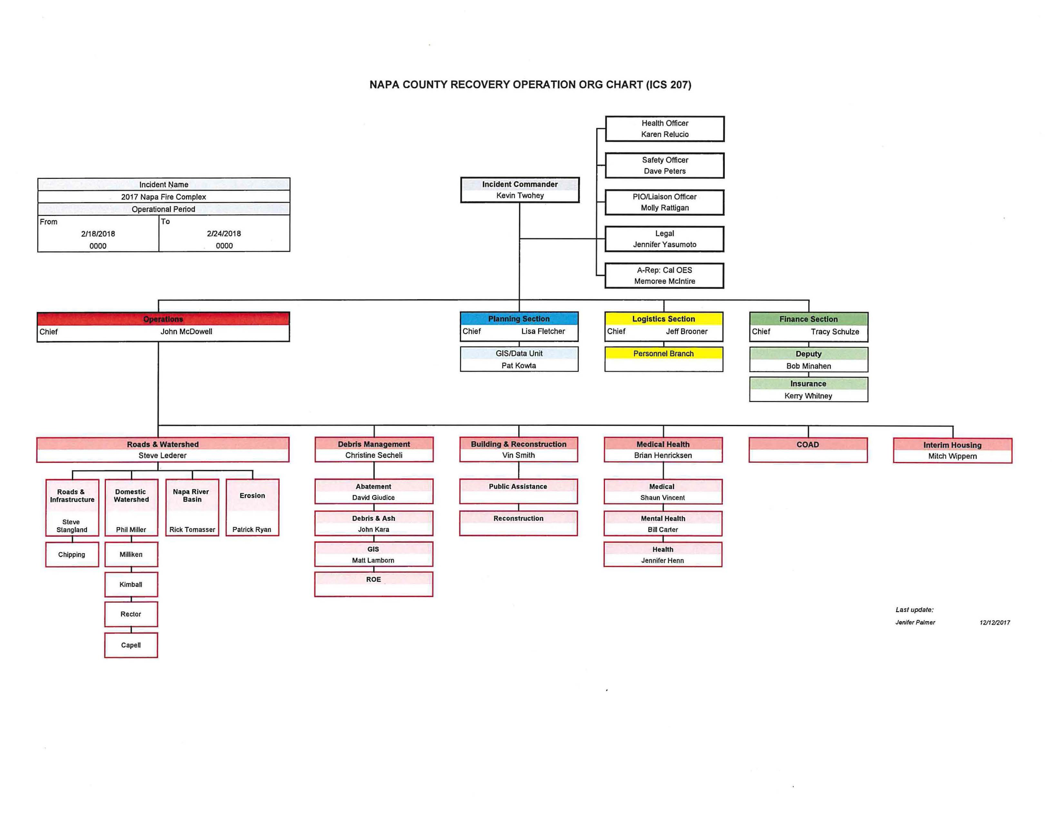

Phases of Emergency Management
Napa County is committed to providing an operational-area-wide program that supports critical and resilient activities for all phases of emergency management. The program provides a common framework for which a variety of agencies across the County may work together effectively.
Emergency management activities are often categorized in phases. In the past, the emergency managers defined four phases: mitigation, preparedness, response, and recovery. However, with increased focus on human-caused disasters, direction from Presidential Preparedness Directive 8 (PPD-8)1, and guidance from the National Governor’s Association and the National Fire Protection Association. Napa County has joined other emergency management organizations in recognizing a fifth phase: prevention.

Prevention
The prevention phase includes activities, tasks, programs, and systems intended to avert or intervene to stop an incident from occurring. Prevention can apply both to human-caused incidents (such as terrorism, vandalism, sabotage, or human error) as well as for naturally occurring incidents (such as earthquakes, floods, or wildfires, etc.). Prevention of human-caused incidents can include applying intelligence and other information to a range of activities that includes such countermeasures as:
- Deterrence operations
- Heightened inspections
- Improved surveillance and security operations
- Investigations to determine the nature and source of the threat
- Law enforcement operations directed at deterrence, preemption, interdiction, or disruption

Preparedness
Before an emergency ever occurs, the County is committed to conducting preparedness activities that include developing plans, training personnel, conducting emergency exercises, educating the public, and arranging to have necessary resources available.
Preparedness activities are part of the implementation of the California Emergency Services Act, the California Master Mutual Aid Agreement, and the California State Emergency Plan.
Preparedness activities fall into two basic areas: readiness and capability.
Readiness activities shape the emergency management framework and create the basis of knowledge necessary to complete a task or mission. Readiness activities might include, but are not limited to:
- Implementing hazard mitigation projects
- Developing hazard analyses
- Developing and maintaining emergency plans and procedures that serve the whole community, especially those with disabilities and others with access and functional needs
- Conducting general and specialized training
- Conducting drills and exercises
- Developing mutual aid agreements and MOUs
- Improving emergency public education and emergency warning systems
Capability activities involve the procurement of items or tools necessary to complete tasks or missions. Capability activities include, but are not limited to:
- Assessing the County and its resources
- Comparing and analyzing anticipated resource requirements against available resources
- Identifying local sources to serve as anticipated resources
- Purchasing new response apparatus, vehicles, personal protective equipment, etc.
- Assessing personnel training needs and providing necessary training

Response
Response is typically divided into three phases. Each phase has distinct considerations, which seldom flow sequentially, often occurring simultaneously. These phases are increased readiness (pre-incident for anticipated events), initial response (first 72 hours), and extended response (response activities beyond the first 72 hours).
Increased readiness is required upon receipt of a warning or in anticipation that an emergency situation is imminent or likely to occur. The County initiates actions to increase its readiness. Increased readiness activities may include, but are not limited to:
- Briefing the Board of Supervisors, County Executive Officer, and other key officials, applicable department representatives, and County employees
- Reviewing the EOP and all relevant annexes, policies, and procedures
- Increasing public information capabilities (i.e., adding, assigning, and/or training personnel, activating JIC, implementing technology support systems, etc.)
- Providing just-in-time training
- Inspecting critical facilities and equipment, including the testing of warning and communications systems
- Recruiting additional staff, registering volunteers, and swearing in disaster service workers, as needed
- Warning at-risk elements of the population
- Conducting precautionary evacuations in the potentially impacted area(s)
- Mobilizing personnel and pre-positioning resources and equipment
- Contacting local (city, county, and special districts), state, and Federal agencies that may provide support
The County‘s initial response activities are performed at the field-level. Emphasis is placed on saving lives and minimizing the effects of the emergency or disaster. Examples of initial response activities include, but are not limited to:
- Making all necessary notifications, including Napa County’s emergency management organization, County departments, Napa Valley Community Organizations Active in Disasters (COAD), external agencies and other involved community partners
- Disseminating warnings, emergency public information, and instructions to the community members of the County
- Conducting evacuations and/or rescue operations
- Caring for displaced persons and treating the injured
- Conducting initial damage assessments and surveys
- Assessing the need for mutual aid assistance
- Restricting movement of traffic/people and unnecessary access to affected areas
- Clearing debris from priority routes
- Developing and implementing Incident Action Plans (e.g., field, EOC, etc.)
The County’s coordination of extended response activities is primarily conducted in the EOC. Extended emergency operations involve the coordination and management of personnel and resources to mitigate an emergency and facilitate the transition to recovery operations. Examples of extended response activities include, but are not limited to:
- Disseminating emergency public information
- Preparing detailed damage assessments
- Proclaiming a local emergency
- Requesting a Governor’s state of emergency proclamation and/or Presidential emergency or major disaster declaration that provides financial and other assistance to state and local governments, certain private nonprofit organizations, and individuals to support response, recovery, and mitigation efforts
- Documenting situation status
- Documenting expenditures
- Coordinating the restoration of vital utility services
- Coordinating mass care and sheltering facilities
- Expanding debris clearance to other priority routes
- Developing and implementing Incident Action Plans (e.g., field, EOC, etc.) for extended
- Operations
- Conducting advance planning activities
- Procuring required resources to sustain operations
- Tracking resource allocation
- Establishing a Local Assistance Center
- Coordinating with local governments and first responder agencies within the OA
- Coordinating with State and Federal agencies working within the OA

Recovery
The phases of recovery, or the “recovery continuum,” as FEMA refers to them, offer a process of interdependent and often concurrent activities that seek to progressively advance a community toward a successful recovery. Decisions made and priorities set early in the recovery process by a community have a cascading effect on the nature and speed of the recovery progress.
While the immediate lifesaving activities are occurring, it is important to begin assessing how soon the response phase can transition to recovery.
Short-term recovery activities include but are not limited to:
- Restoration of essential services and social/economic functions
- Transition from EOC operations to Recovery Operations Center (ROC) or County departments, based on their functional responsibilities
- Damage assessment
- Debris management
- Local Assistance Center (LAC) operations
- Provision of temporary housing
- Deployment of financial management systems for cost recovery through state and federal reimbursement programs
- Activities to support proclamations and requests for assistance
- Advance planning for long-term recovery needs
Long-term recovery activities include but are not limited to:
- Reconstructing facilities and infrastructure
- Planning and rebuilding of housing
- Implementing waivers, zoning changes, and other land-use legislation to promote recovery
- Providing long-term assistance to displaced families, including financial support as well as social and health services
- Restoring the local economy to pre-disaster levels
- Integrating mitigation strategies into rebuilding efforts
- Recovering disaster-related costs for infrastructure restoration through state and federal grant programs
In addition to a discrete set of activities and funding mechanisms, recovery is also an aspirational planning process that requires the sustained engagement of many partners to enact a shared vision for an improved and more resilient community.

Mitigation
Mitigation efforts occur both before and after emergencies or disasters. The term “hazard mitigation” refers to actions or strategies that can reduce or eliminate long-term risks caused by disasters. Mitigation strategies aim to break the cycle of destruction and damage caused by disasters by reducing risks before and after disasters.
Multiple jurisdictions participated in the development, review, and approval of a comprehensive list of mitigation strategies identified in Napa County’s MJHMP. Participants in that planning process included Napa County, City of Calistoga, City of St. Helena, Town of Yountville, City of American Canyon, Napa County Office of Education, Napa Valley College, Napa County Flood Control and Water Conservation District, and the Howell Mountain Mutual Water Company. The City of Napa has developed its own hazard mitigation plan but participated in the review of the MJHMP as a planning partner. Participating jurisdictions individually selected a range of appropriate mitigation actions to work toward achieving the MJHMP’s goals, which are described compiled in Volume 2 of the MJHMP. Mitigation efforts include, but are not limited to:
- Amending local ordinances and statutes, such as zoning ordinances, building codes, and other enforcement mechanisms
- Initiating structural retrofitting measures
- Assessing tax levies or abatements
- Emphasizing public education and awareness
- Assessing and altering land use planning
Napa County is committed to developing better hazard and risk information to use in making those trade‐offs. The goal is not to create a disaster‐proof region, but a disaster-resistant one.

Training and Exercises
Napa County OES will develop an annual training and exercise plan for members of the Napa County emergency management organization. OES will inform County departments, Operational Area cities and special districts, and Cal OES Region II of training and exercise opportunities associated with emergency management. Departments with responsibilities under the Napa County EOP are responsible for ensuring their personnel are properly trained to carry out their responsibilities under the Plan. Individual departments will be responsible for maintaining training records for their respective employees.
County OES will determine the appropriate level(s) of SEMS instruction for each member of the Napa County emergency organization and inform their respective departments. The determination will be based on individuals' potential assignments during emergency response.
County OES will ensure that all EOC personnel can demonstrate and maintain, to the level deemed appropriate, the functional capabilities for the positions they may need to staff during an emergency.
County OES is responsible for the planning and conducting of emergency exercises for Napa County. Exercises will be conducted on a regular basis to maintain readiness and allow emergency responders to become familiar with the procedures, facilities, and systems that they will actually use in emergency situations. Additional emergency exercises throughout the county may be hosted and conducted by partner agencies.
Operational Area member jurisdictions will be invited to participate in all relevant exercises sponsored by the County OES. County OES will follow the procedures outlined in the Homeland Security Exercise and Evaluation Program (HSEEP) for exercise development, execution, after-action documentation, and improvement plan development. This information can be provided to Cal OES to meet local exercise requirements.

Plan Development and Maintenance
The Napa County Emergency Operations Plan (EOP) will be reviewed and revised by the Emergency Services Council annually, or after any full activation. Napa County OES is responsible to updating and maintaining the plan. Every five years, the entire emergency operations plan will be reviewed, updated, republished, and redistributed. As a “living document,” the plan may be modified on an ongoing basis as a result of post‐incident analyses, post‐exercise critiques and changes in policy. Such changes include updated responsibilities, procedures, laws, rules, or regulations pertaining to emergency management and operations change.
Those agencies and organizations having assigned responsibilities under this plan are obligated to inform Napa County OES when changes occur or are imminent. Proposed changes will be submitted, in writing, to the Napa County OES.
Changes will be published and distributed to County departments and Operational Area partners. This may be in the form of suggested “pen and ink” changes to be noted in paper copies of the EOP, new pages for insertion into paper copies of the EOP or updated electronic copies of the EOP. All agencies within the Napa County OA will be encouraged to but are not required to participate in the planning and update process. A record of revisions to this plan will be maintained by the Napa County OES on the Record of Changes and Distribution in Section A.

Authorities and References
This plan abides by all relevant federal, state, and local laws, policies, and guidelines. Those policies relevant to this document are listed below. Each additional annex and/or appendix will also include a listing of the policies by which they abide.
Federal
- Robert T. Stafford Emergency Disaster Relief and Emergency Assistance Act (42
- USC § 5121 et seq.)
- • Federal Disaster Relief Regulations: 44 CFR Part 206
- • National Incident Management System, HSPD-5, Management of Domestic
- Incidents
- • National Response Plan, U.S. Department of Homeland Security, December 2004
- • National Response Framework, U.S. Department of Homeland Security, March
- 2008
- FEMA Guidance on Planning for Integration of Functional Needs Support Services in General Population Shelters
- Americans with Disabilities Act of 1990
- Americans with Disabilities Act of 2010
- Individuals with Disabilities Education Act of 1975
- Post-Katrina Emergency Management Reform Act of 2006 Rehabilitation Act of 1973
- Rehabilitation Act 508
- Fair Housing Act Amendments of 1988
- Architectural Barriers Act of 1968
- Twenty-First Century Communications and Video Accessibility Act of 2010
- Telecommunications Act of 1996
- ADA Checklist for Emergency Shelters
- ADA Best Practices Tool Kit for State and Local Governments
- DOJ - Tips & Tools for Reaching Limited English Proficient Communities in Emergency Preparedness
- Rehabilitation Act of 1973
- Fair Housing Act of 1968
- FEMA, Comprehensive Planning Guide (CPG) 101, v.2
State
- California Emergency Services Act: California Government Code, Title 2, Division 1, Chapter 7,
- Standardized Emergency Management System Regulations: California Code of Regulations (CCR) Title 19, Division 2
- California Disaster Assistance Act Regulations: California Code of Regulations, Title 19,
Division 2, Chapter 6
- California Government Code, Title 1, Chapter 4, Division 8, Section 3100, (Disaster Service Workers)
- Physician or surgeon, etc., services in emergency California Government Code, Title 2, Chapter 1, Division 7, Section 8659
- Continuity of Government: California Government Code, Title 1, Chapter 4, Division 8, Section 8635,
- California Master Mutual Aid Agreement
- Orders and Regulations that may be Selectively Promulgated by the Governor during a State of Emergency
- Orders and Regulations that may be Selectively Promulgated by the Governor during a State of War Emergency
- California Water Code (CWC), § 128 (Department of Water Resources ‐ Flood Fighting)
- Assembly Bill 2311 (Brown, Chapter 520, Statutes of 2016)
- California Emergency Services Act
- Cal OES OFAN Guidance on Planning and Responding to the Need of People with Disabilities and Older Adults California Building Code, Chapter 11B - Accessibility to Public Buildings
- Local Assistance Center Guide for Local Governments
- California State Emergency Plan, 2017
Local/ Operational Area
- Napa County Code of Ordinances 2.80.080 Emergency Plan
- Napa County Code of Ordinances 5.14.060 Emergency Alert
- Napa County Code of Ordinances 2.80.070 Emergency Organization
- Napa County Code of Ordinances 8.56.090 Emergency Removal
- Napa County Code of Ordinances 16.04.820 Emergency Abatement
- Napa County Code of Ordinances 2.36.100 Emergency Purchases
- Napa County Code of Ordinances 2.100.260 Emergency Employment
- Napa County Code of Ordinances 2.80.065 Public Health Emergency
- Napa County Code of Ordinances 2.80.020 Emergency definition
- Napa County Code of Ordinances 12.04.130 Emergency Work
- Napa County Code of Ordinances 8.70.066 Emergency Action
- Napa County Code of Ordinances 2.80.030 Emergency Services Council- Created- Membership
- Napa County Planning Process Guide
- Napa County, Emergency Operations Plan, 2009
- Napa County Health and Human Services Agency (HHSA) Concept of Operations Plan (CONPLAN)
Mutual Aid
- California Disaster and Civil Defense Master Mutual Aid Agreement
- California Fire and Rescue Emergency Plan
- California Law Enforcement Mutual Aid Plan
- Federal Disaster Relief Act of 1974 (Public Law 93‐288)
- California Public Health and Medical Emergency Operations Manual (EOM)
Continuation of Government/Operations Authority
- Continuity of Government in California (Article IV, Section 21 of the State Constitution)
- Preservation of Local Government (Article 15 of the California Emergency Services Act)
- Temporary Seat of State Government (Section 450, Title 1, Division 3, Chapter 1 of the Government Code)

Appendix A: Acronyms
AA/CA | After Action /Corrective Action
ARC | American Red Cross
CalOES | California Office of Emergency Services
CLETS | California Law Enforcement Telecommunications System
COG | Continuity of Government
COOP | Continuity of Operations
CSTI | California Specialized Training Institute
DHS | Department of Homeland Security
DOC | Departmental Operations Center
EAS | Emergency Alert System
EMS | Emergency Medical Services
EOC | Emergency Operations Center
EOP | Emergency Operations Plan
ERT | Emergency Response Team
EF | Emergency Function (California EOP)
ESF | Emergency Support Function
FEMA | Federal Emergency Management Agency
GIS | Geographical Information System
GPS | Global Positioning System
HMGP | Hazard Mitigation Grant Program
HSEEP | Homeland Security Exercise and Evaluation program
HSPD | Homeland Security Presidential Directive
IAP | Incident Action Plan
IC | Incident Commander
JIC | Joint Information Center
JIS | Joint Information System
JOC | Joint Operations Center
LAC | Local Assistance Center
NFIP | National Flood Insurance Program
NIMS | National Incident Management System
NRF | National Response Framework
OA | Operational Area
ODP | Office of Domestic Preparedness
OES | Office of Emergency Services
PA | Public Assistance
PDA | Preliminary Damage Assessment
PIO | Public Information Officer
RIMS | Response Information Management System
REOC | Regional Emergency Operations Center
SBA | Small Business Administration
SEMS | Standardized Emergency Management System
SITREP | Situation Report
SNS | Strategic National Stockpile
SOC | State Operations Center (CA)
SOP | Standard Organizations Procedure
VOAD | Voluntary Organizations Active in Disasters
WMD | Weapon of Mass Destruction

Appendix B: Definitions
After Action/Corrective Action report: A written report that provides a source for documentation of response and recovery activities. It is used to identify problems and successes that occurred during emergency operations, and to analyze the effectiveness of components of the SEMS. The Corrective Action describes and defines a plan of action for implementing improvements, including mitigation activities, and a means of tracking them to completion.
Command post: A physical location designated at the beginning of any disaster where the Incident Commander is stationed. Depending on conditions, the command post may be moved. Multiple incidents would have multiple command posts.
Demobilize: When specific personnel or equipment are no longer needed, they are returned to the original dispatch location.
Department Operations Center (DOC) A facility used by a discipline or agency as a department level EOC. Examples are departments within a political jurisdiction such as fire, police, public works as well as agency divisions, districts, or regional offices. DOCs can be used at all SEMS levels above the field response level, depending on the impacts of the emergency, demographic nature of the agency or organization, local policy and procedures, and configuration of communications systems.
Disaster Service Worker: All volunteers (including veterinarians) must be sworn in as disaster service workers BEFORE a disaster. Taking this oath affords them coverage if injured through the State Workers’ Compensation Fund. It also allows for more protection than the Good Samaritan Act with respect to liability issues.
Emergency: A condition of disaster or extreme peril to the safety of persons or property. Emergencies can be small or large.
Emergency Operations Center (EOC): A location that monitors and coordinates the disaster response. EOC facilities are found at local governments, operational areas, regions, and states.
Emergency response agency: Any organization responding to an emergency or providing mutual aid support to such an organization whether in the field, at the scene of an incident, or to the operations center.
Emergency response personnel: Personnel involved with an agency’s response to an emergency.
Incident Action Plan (IAP): When a disaster occurs, a written or oral plan is drafted by the Planning Section with the Incident Commander which establishes goals and identifies the operational period.
Incident Commander (IC): The individual responsible for all incident activities. The IC has overall authority and responsibility for incident operations.
Incident Command System (ICS): A nationally used, standardized, on‐scene emergency management system. Liaison Officer: One person will be assigned to aid in the coordination of the response by being the point of contact for other agencies responding to an incident. The Liaison Officer reports directly to the IC.
Memorandum of Understanding: A written agreement between two or more parties to establish official partnerships. It expresses a convergence of will between the parties, indicating an intended common line of action.
Mitigation: Before or after a disaster, there are actions that can be taken to reduce the impact of the event.
Multiagency or interagency coordination: Agencies working together at any SEMS level to facilitate decisions.
Mutual Aid: Voluntary provision of services and facilities when existing resources prove to be inadequate. California mutual aid is based upon the State’s Master Mutual Aid Agreement. There are several mutual aid systems included in the mutual aid program.
Operational Area: An intermediate level of the state emergency services organization consisting of a county and all political subdivisions within the county area.
Operational Period: In each action plan, there will be a period of time specified in which identified goals must be accomplished.
Operations Section Chief: The Operations Section Chief directly manages all incident tactical activities and implements the Incident Action Plan.
Public Information Officer (PIO): One person is designated to be the ONLY contact for the media to ensure that accurate information about the disaster response is released. Press releases are approved by the Incident Commander prior to release.
Span of control: To ensure the most effective disaster response, the optimum number of people reporting to one supervisor is no more than five people and the maximum is seven people.
Triage: When there are many injuries, those with the most life-threatening injuries are treated first (if they have a good prognosis with treatment).

