Napa County Department of

Public Works

**Title VI Implementation Program Plan**

**2018**

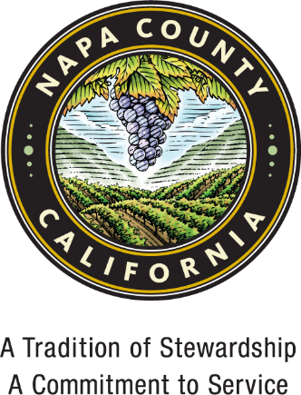

Approval of Napa County Public Works Title VI Implementation Program Plan

NAPA COUNTY, a political subdivision of the State of California

By_______________________________________

BRAD WAGENKNECHT, Chair

Board of Supervisors

|  |  |  |
| --- | --- | --- |
| APPROVED AS TO FORM  Office of County Counsel  By:  *Thomas S. Capriola*  Deputy County Counsel  Date: July 31, 2018 | APPROVED BY THE NAPA COUNTY  BOARD OF SUPERVISORS  Date:  Processed By:    Deputy Clerk of the Board | ATTEST: JOSE LUIS VALDEZ  Clerk of the Board of Supervisors  By |

**TABLE OF CONTENTS**

I. Introduction 3

II. Title VI Policy Statement 4

III. Organization, Staffing, and Structure 5

IV. Title VI Program Manager 7

V. Title VI Program Monitoring 8

VI. Public Information Requirements 10

**TITLE VI POSTER – ENGLISH** 11

**TITLE VI POSTER - SPANISH** 12

**TITLE VI POSTER - TAGALOG** 13

VII. Limited English Proficiency Four Factor Analysis 14

VIII. Complaints Procedure 19

**TITLE VI COMPLAINT FORM - ENGLISH** 21

**TITLE VI COMPLAINT FORM - SPANISH** 22

**TITLE VI COMPLAINT FORM – TAGALOG** 23

IX. Data Collection Procedures 24

X. Title VI Training 25

XI. Annual Accomplishments Report 27

APPENDIX 29

**APPENDIX**

**Attachment 1 - DBE Subcontractor Utilization Form**

**Attachment 2 - Federal Provisions**

**Attachment 3 – Good faith (sample DBE/MBE/WBE advertisement)**

**Attachment 4 - Employment Notices**

**Attachment 5 - Site Meeting Notifications (English, Spanish & Tagalog)**

**Attachment 6 – Photos of Posting of Title VI (English, Spanish & Tagalog)**

**Attachment 7 – Website Posting**

# **Introduction**

The Napa County Public Works Department is a recipient of Federal Highway Administration (FHWA) federal-aid highway funds and Federal Aviation Administration (FAA) federal-aid airport funds and funding from Federal Emergency Management Agency (FEMA), the Environmental Protection Agency and other federal sources. Recipients of federal funds are required to comply with various nondiscrimination laws and regulations, including Title VI of the Civil Rights Act of 1964 (Title VI). Title VI forbids discrimination against anyone in the United States on the basis of race, color, or national origin in the programs and activities of an agency receiving federal financial assistance. In addition to Title VI, the other nondiscrimination statutes that afford legal protection are: Section 162 (a) of the Federal-Aid Highway Act of 1973 (23 USC 324) (sex), Age Discrimination Act of 1975 (age), and Section 504 of the Rehabilitation Act of 1973/Americans with Disabilities Act of 1990 (disability). Together, these requirements define an over-arching Title VI Program. It is important to also understand that Title VI and the additional nondiscrimination requirements apply to all Napa County Public Works Department programs even when only one program receives federal funds.

The Civil Rights Restoration Act of 1987 defined the word “program” to make clear that discrimination is prohibited throughout an entire agency if any part of the agency receives federal funds. Simply stated, the Napa County Department of Public Works is to ensure that none of its activities or programs treats any part of a community any differently than another. The Napa County Department of Public Works is committed to achieving full compliance. Through this Title VI Program Plan, the Department expects every manager, supervisor, employee, and sub recipient of federal-aid funds administered by the Public Works Department to be aware of and apply the intent of Title VI and related nondiscrimination statutes in performing assigned duties. The Title VI Program Plan focuses on the functional areas with significant public contact responsibilities and provides the policy direction necessary to ensure compliance with Title VI and related nondiscrimination statutes.

Napa County Public Works Department, as a recipient, to prepare a plan to clarify roles, responsibilities, and procedures to ensure compliance with Title VI and related nondiscrimination statutes. Title 23 of the Code of Federal Regulations (CFR) 200.9(b) (11) requires an updated Title VI Program Plan every three years by October 1.

The Napa County Public Works Department relies on its Title VI Program Manager to work with staff to implement and monitor compliance with Title VI nondiscrimination requirements.

# **Title VI Policy Statement**

Title VI of the Civil Rights Act of 1964 prohibits discrimination on the basis of race, color, or national origin in programs and activities receiving Federal financial assistance. Specifically, Title VI provides that "no person in the United States shall, on the ground of race, color, or national origin, be excluded from participation in, be denied the benefits of, or be subjected to discrimination under any program or activity receiving Federal financial assistance" (42 U.S.C. Section 2000d). Presidential Executive Order 12898 addresses environmental justice in minority and low-income populations. Presidential Executive Order 13166 addresses services to those individuals with limited English proficiency.

Napa County Public Works Department (Department) is committed to ensuring that no person is excluded from participation in or denied the benefits of its services on the basis of race, color, or national origin, as protected by Title VI. This plan was developed to guide the Department in its administration and management of Title VI related activities for the public and vendors.

# **Organization, Staffing, and Structure**

**Department Function and Responsibilities**

**Mission**

The Napa County Public Works Department is dedicated to sustaining health, safety, quality of life and protection of natural resources by providing and maintaining public facilities and services in partnership with the community and other public agencies for current and future residents, workers, animals and visitors of Napa County.

**Function and Responsibilities**

The Department has many programmatic responsibilities and oversees a variety of activities. The Department is organized into four divisions as follows:

* Engineering
* Construction and Design Engineering: Oversees and implements the County's Capital Improvement Program, including buildings and civil projects.
* Roads: Protects, preserves, enhances and improves the existing County road system by operating and maintaining 446 miles of County roads so that they are safe, reliable, and accessible for all users. The vast majority of roadway miles are rural in nature and almost one third of these constitute the County’s major arterial or collector network.
* County Surveyor: Administers County surveys and maintains records of governmental surveys and lines. Processes lot line adjustments and subdivision maps.
* Flood Control and Water Resources
* Environmental Services and Napa Flood Project: Public Works provides staffing for the Napa County Flood Control & Water Conservation District activities, which include managing the Measure "A" funded Napa River Flood Protection Project and performing a variety of watershed maintenance functions.
* Resort Improvement Districts: Public Works provides staff to operate water and sewer service for Lake Berryessa Resort Improvement District and Napa Berryessa Resort Improvement District.
* Natural Resources: The Natural Resources Conservation (NRC) Division programs include Integrated Waste Management, Water Resources Conservation, and Energy Efficiency.
* General Services
* Airport: Manages the operation and maintenance of the Napa County Airport.
* Animal Shelter: The Animal Shelter is responsible for receiving, housing and caring for stray and unwanted animals, conducting adoption, spay, and neuter programs and issuing dog licenses and kennel permits.
* Property Management: Property Management provides ongoing custodial, maintenance and rehabilitation work on County facilities. It provides for the repair and maintenance of the County’s mechanical equipment and other machinery. Oversight is provided for a variety of maintenance services including all landscaping and grounds keeping operations on County premises, the Cuttings Wharf Boat Launch and the Solano Avenue Bike Rest facilities. Utility costs for County buildings are also monitored and managed within this budget unit.
* Fleet: This Division provides a working capital fund for the purchase and operation and maintenance of the County-owned vehicle fleet and road maintenance equipment.
* Real Estate: Provides real estate management including executing leases, space licenses, acquisition and disposal of real property and ongoing management of leased spaces.
* Administration
* Administration and Business Services: Provides management, administrative, clerical, fiscal and accounting support to all Public Works functions.
* Special Districts: The Division provides contracted services for County Service Area No. 3, Upper Valley Waste Management Agency, Silverado Community Services District, Monticello Public Cemetery District, Lake Berryessa Resort Improvement District, Napa Berryessa Resort Improvement District and the Devlin Road Community Facilities District.

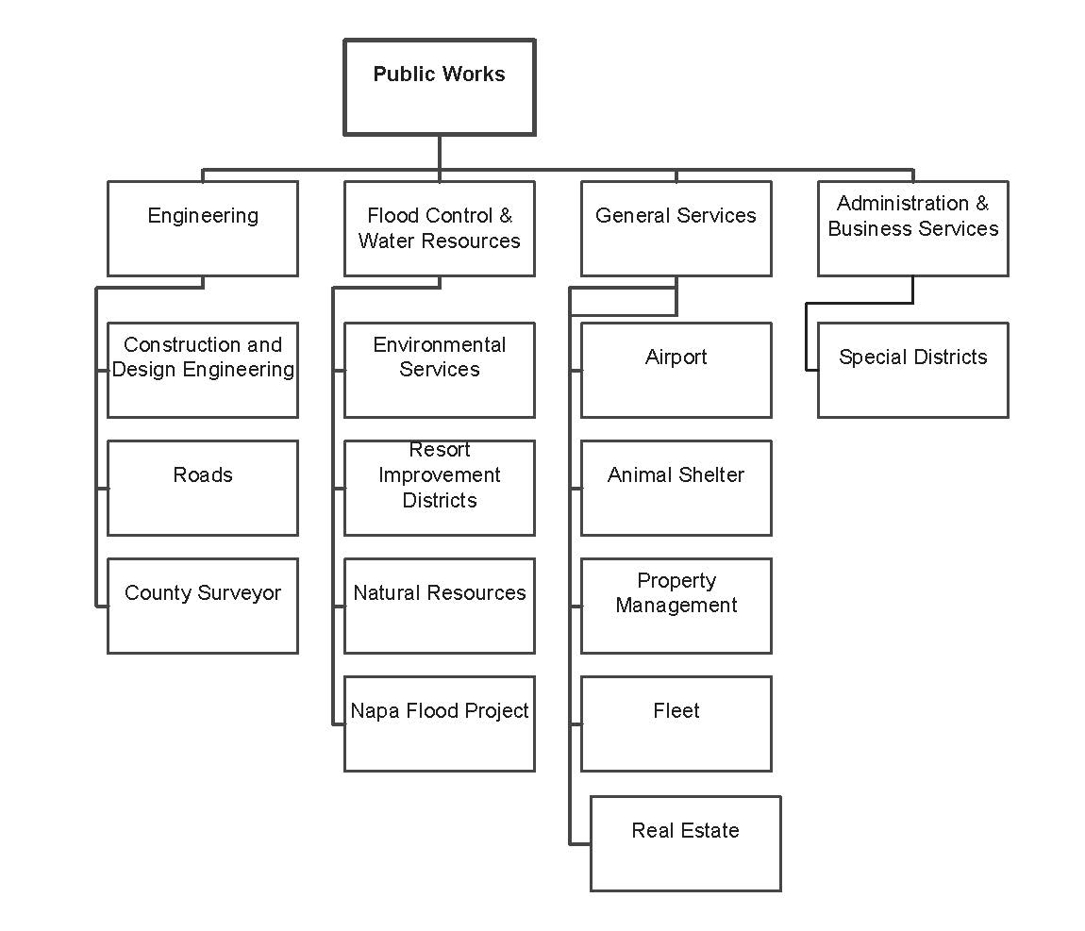

# **Title VI Program Manager**

The Napa County Public Works Director is ultimately responsible for assuring full compliance with the provisions of Title VI of the Civil Rights Act of 1964 and related statutes within the Public Works Department and has directed that non-discrimination is required of all employees, contractors, and agents pursuant to 23 CFR Part 200 and 49 CFR Part 21.

The Napa County Public Works Department has identified the Title VI Coordinator s to carry out the Title VI program. The Title VI Coordinator is:

Napa County Public Works Department

Title VI Program Manager

Mallika Ramachandran, P.E

1195 Third Street, Ste 101

Napa, CA 94559

Ph: 707-259-8194

Email: mallika.ramachandran@countyofnapa.org

The Napa County Public Works Department through its Title VI Program Manager works with staff to implement and monitor compliance with Title VI nondiscrimination requirements.

The Title VI Manager is responsible for:

* Preparing a Title VI plan and annual report on the Department’s behalf;
* Developing procedures for the prompt processing and disposition of complaints;
* Investigating complaints and compiling a complaint log;
* Developing procedures for the collection and analysis of statistical data;
* Developing a program to conduct Title VI reviews of program areas;
* Conducting annual Title VI assessments of pertinent program areas;
* Developing Title VI information for dissemination;
* Establishing procedures for resolving deficiencies and writing the remedial action needed for resolution.

# **Title VI Program Monitoring**

**Title VI Assurances**

The Department is required to monitor and ensure that contractors and subrecipients hired (hereafter collectively referred to as CONTRACTOR) for Department projects agree to the following assurances:

1. Compliance with Regulations: CONTRACTOR shall comply with the regulations relative to nondiscrimination in federally assisted programs of the Department of Transportation, Title 49, Code of Federal Regulations, Part 21, as they may be amended from time to time, (hereinafter referred to as the REGULATIONS), which are herein incorporated by reference and made a part of this agreement.
2. Nondiscrimination: CONTRACTOR, with regard to the work performed by it during the AGREEMENT, shall not discriminate on the grounds of race, color, sex, national origin, religion, age, or disability in the selection and retention of sub-applicants, including procurements of materials and leases of equipment. CONTRACTOR shall not participate either directly or indirectly in the discrimination prohibited by Section 21.5 of the Regulations, including employment practices when the agreement covers a program set forth in Appendix B of the Regulations.
3. Solicitations for Sub-agreements, Including Procurements of Materials and Equipment: In all solicitations either by competitive bidding or negotiation made by CONTRACTOR for work to be performed under a Sub-agreement, including procurements of materials or leases of equipment, each potential sub-applicant or supplier shall be notified by CONTRACTOR of the CONTRACTOR’S obligations under this Agreement and the Regulations relative to nondiscrimination on the grounds of race, color, or national origin.
4. Information and Reports: CONTRACTOR shall provide all information and reports required by the Regulations, or directives issued pursuant thereto, and shall permit access to its books, records, accounts, other sources of information, and its facilities as may be determined by the California Department of Transportation, FHWA or other federal funding agency to be pertinent to ascertain compliance with such Regulations or directives. Where any information required of CONTRACTOR is in the exclusive possession of another who fails or refuses to furnish this information, CONTRACTOR shall so certify to the California Department of Transportation or the FHWA as appropriate, and shall set forth what efforts CONTRACTOR has made to obtain the information.
5. Sanctions for Noncompliance: In the event of CONTRACTOR’s noncompliance with the nondiscrimination provisions of this agreement, the California Department of Transportation shall impose such agreement sanctions as it or the FHWA may determine to be appropriate, including, but not limited to:
6. Withholding of payments to CONTRACTOR under the Agreement within a reasonable period of time, not to exceed 90 days; and/or
7. Cancellation, termination or suspension of the Agreement, in whole or in part.
8. Incorporation of Provisions: CONTRACTOR shall include the provisions of paragraphs (1) through in every sub-agreement, including procurements of materials and leases of equipment, unless exempt by the Regulations, or directives issued pursuant thereto.

CONTRACTOR shall take such action with respect to any sub-agreement or procurement as the California Department of Transportation, FHWA or other deferral funding agency may direct as a means of enforcing such provisions including sanctions for noncompliance, provided, however, that, in the event CONTRACTOR becomes involved in, or is threatened with, litigation with a sub-applicant or supplier as a result of such direction, CONTRACTOR may request the California Department of Transportation enter into such litigation to protect the interests of the State, and, in addition, CONTRACTOR may request the United States to enter into such litigation to protect the interests of the United States.

**Sub-recipients**

All subcontractors and vendors who receive payments from County where funding originates from any federal assistance are subject to the provisions of Title VI of the Civil Rights Act of 1964 as amended.

Written contract shall contain non-discrimination language, either directly or through the bid specification package which becomes an associated component of the contract.

# **Public Information Requirements**

Title VI information posters shall be prominently and publicly displayed in the County’s facilities. The name of the DBE Liaison is available on the County’s Public Works website, at http://www.countyofnapa.org/PublicWorks/. Additional information relating to nondiscrimination obligations can be obtained from the Civil Rights Coordinator. **See Attachment 6**

## **TITLE VI POSTER – ENGLISH**



## **TITLE VI POSTER - SPANISH**



## **TITLE VI POSTER - TAGALOG**



# **Limited English Proficiency Four Factor Analysis**

**Introduction**

To clarify Title VI of the Civil Rights Act of 1964, President William J. Clinton signed “Executive Order 13166: Improving Access to Service for Persons with Limited English Proficiency (LEP)” in August 2000.

The purpose of this executive order was to ensure accessibility to programs and services to otherwise eligible persons who are not proficient in the English language. This executive order stated that individuals who have a limited ability to read, write, speak, or understand English are entitled to language assistance under Title VI of the Civil Rights Act of 1964. The Executive Order states that:

“Each federal agency shall prepare a plan to improve access to its federally conducted programs and activities by eligible LEP persons. Each plan shall be consistent with the standards set forth in the LEP Guidance, and shall include the steps the agency will take to ensure that eligible LEP persons can meaningfully access the agency’s programs and activities.”

Not only do all federal agencies have to develop LEP plans as a condition of receiving federal financial assistance, recipients must comply with Title VI and LEP guidelines of the federal agency from which funds are provided as well. Federal financial assistance includes grants, training, and use of equipment, donations of surplus property, and other assistance. Title VI applies to a recipient’s entire program or activity. This means all parts of a recipient’s operations are covered, even if only one part of a recipient’s organization receives the federal assistance. The Napa County Public Works Department receives funds from the US Department of Transportation (US DOT) via the Federal Highway Administration (FHWA) for its County roads and receives funds from the Federal Aviation Administration (FAA) for its airport. The Department also receives funding from FEMA, EPA and other federal sources.

The US Department of Transportation published Policy Guidance Concerning Recipients’ responsibilities towards Limited English Proficient individuals in the Federal Register of December 14th, 2005. This guidance applies to all US DOT funding recipients, which include state departments of transportation, state motor vehicle administrations, airport operators, metropolitan planning organizations, and regional, state, and local transit operators, among many others.

**Designing an Effective LEP Policy**

**Elements of an Effective LEP Policy:**

The US Department of Justice, Civil Rights Division has developed a set of elements that may be helpful in designing an LEP policy or plan. These elements include:

1. Identifying LEP persons who need language assistance
2. Evaluating accessibility to available transportation services through a Four-Factor Analysis
3. Identifying ways in which language assistance will be provided
4. Training Staff
5. Providing notice to LEP persons

These recommended plan elements have been incorporated into this plan.

**Methodology for Assessing Needs and Reasonable Steps:**

The US DOT guidance outlines four factors that should be analyzed in order to assess the recipient agency’s language needs. The objective of this Four-Factor Analysis is to determine the reasonable steps the recipient should take to ensure meaningful access to services for LEP persons. The four factors include:

1. The **number or proportion** of LEP persons eligible to be served or likely to be encountered by a program, activity, or service of the recipient or grantee.
2. The **frequency** with which LEP individuals come in contact with the program.
3. The **nature** and importance of the program, activity, or service provided by the recipient to the LEP Community.
4. The **resources** available to the Napa County Public Works Department and overall cost.

The greater the number or proportion of eligible LEP persons, the greater the frequency with which they have contact with a program, activity, or service and the greater the importance of that program, activity, or service, the more likely enhanced language services will be needed. The intent of DOT’s guidance is to suggest a balance that ensures meaningful access by LEP persons to critical services while not imposing undue burdens on small organizations and local governments. Smaller recipients with more limited budgets are typically not expected to provide the same level of language service as larger recipients with larger budgets.

In order to assess the needs of the County in terms of language assistance to LEP individuals, the plan analyzed a variety of data sources. Census data was consulted to determine the languages spoken by LEP individuals. The plan was also informed by an informal survey completed by the Public Works Department members of staff who interact with the community as part of their job. Given the number of LEP individuals, as displayed in Table #1, the probability of encountering an LEP individual is fairly low. However, given that many of our services just as road maintenance, flood protection and animal services play a role in the health and safety of our community, it is important that we ensure accessibility to all of the Department’s programs, services and activities.

**The Four-Factor Analysis:**

This plan uses the recommended four-factor analysis as outlined above. Each of the following factors is examined to determine the level and extent of language assistance measures required to sufficiently ensure meaningful access to Napa County Public Works Department services for LEP individuals.

Recommendations are then based on the results of the analysis.

**Factor 1: The Proportion, Numbers and Distribution of LEP Persons**

The Census Bureau has a range for four classifications of how well people speak English, these include: ‘very well,’ ‘well,’ ‘not well,’ and ‘not at all.’ For the purposes of this plan, Limited English Proficient persons are considered people that speak English less than ‘very well’ as.

The 2016 American Community Survey Data for Napa County indicates that 47,137 (35%) of individuals in the County speak a language other than English. Of those individuals, 21,472 have identified themselves as speaking English less than ‘very well’, which represents 16% of the County’s population 5 years and older. Of the individuals that speak English less than very well, 18,166 speak Spanish (or 85% of the total population that speaks English less than very well), 2,431 speak Asian and Pacific Island languages, 721 speak Indo-European languages other than Spanish, and 479 speak other languages.

**Table #1: Language Spoken at Home**

|  |  |  |  |
| --- | --- | --- | --- |
|  | **Total Number of Speakers** | **Speak English Less than "very well"** | **Speak English Less than “Very Well” as Percent of total population 5 years old and over** |
| **Population 5 years and over** | **133,137** | **21,472** | **16%** |
| **Speak a language other than English** | **47,453** | **21,472** | **16%** |
| *Spanish* | 37,347 | 18,166 | 13.6% |
| *Other Indo-European Languages* | 3,241 | 721 | 0.5% |
| *Asian and Pacific Island languages* | 6,386 | 2,431 | 1.8% |
| *Other languages* | 479 | 154 | 0.1 % |

Source: U.S. Census Bureau, 2012-2016 American Community Survey 5-Year Estimates

**Factor 2: Frequency of Contact with LEP Individuals**

The Napa County Public Works Department has conducted an informal survey of its employees to help estimate the frequency with which the department interacts with LEP individuals. The survey was completed by a representative sample of the Department’s staff, including employees from all program and service areas. Employees were asked about the frequency of their interactions with LEP individuals both in the office and out in the field. Frequency ranged from “not at all” to “daily” depending on their position. Staff with field responsibilities noted they were likely to encounter a LEP person.

**Factor 3: The Nature and Importance of the Program, Activity or Service to LEP Individuals**

The Napa County Public Works Department’s main function is to maintain the unincorporated road network, flood control facilities, the airport, County buildings, the animal shelter, and parks and recreation facilities throughout the unincorporated Napa County. It is believed that denial or delay of access to services or information provided by the Napa County Public Works Department could have serious implications on an LEP individual. Services that impact residents’ health and safety are of particular importance, such as water resources, animal control, sewer, road maintenance for fire protection and other emergency services. It can therefore be determined that denial of services to an LEP individual could have significant detrimental effect on that person.

**Factor 4: The Resources available to the Public Works Department and Overall Cost**

The US DOT Guidance Concerning Recipients’ Responsibilities to LEP Persons published in the Federal Register, December 14, 2005, states:

*“A recipient’s level of resources and the costs imposed may have an impact on the nature of the steps it should take in providing meaningful access for LEP persons. Smaller recipients with more limited budgets are not expected to provide the same level of language services as larger recipients with larger budgets. In addition, “reasonable steps” may cease to be reasonable where the costs imposed substantially exceed the benefits. Recipients should carefully explore the most cost-effective means of delivering competent and accurate language services before limiting services due to resource concerns.”*

Based on this guidance, the Napa County Department of Public Works has reviewed the resources it has available to provide language resources in order to estimate the level of language services it can provide. Given the concentration of LEP individuals in the County, the County has determined that it has the resources to translate its vital documents into Spanish, which is spoken by 85% of LEP individuals in the County, and Tagalog which falls under the “Safe Harbor” provision (as discussed below). Other languages will be provided translation services upon request. The cost associated with the necessary translation of documents will be allocated on an as-needed basis and charged to the program that is responsible for the information being requested.

**SAFE HARBOR PROVISION**

Because the Department of Transportation (DOT) guidelines regarding “Safe Harbor Provision” for translation of written materials requires the identification of “Safe Harbor Languages”, careful attention must be paid to the absolute numbers as well as the percentage of the population that do not speak English in the development of the LEP Plan. FTA Circular 4702.1B states the following with respect to the Safe Harbor Provision:

*The Safe Harbor Provision stipulates that, if a recipient provides written translation of vital documents for each eligible LEP language group that constitutes five percent (5%) or 1,000 persons, whichever is less, of the total population of persons eligible to be served or likely to be affected or encountered, then such action will be considered strong evidence of compliance with the recipient’s written translation obligations. Translation of non-vital documents, if needed, can be provided orally. If there are fewer than 50 persons in a language group that reaches the five percent (5%) trigger, the recipient is not required to translate vital written materials but should provide written notice in the primary language of the LEP language group of the right to receive competent oral interpretation of those written materials, free of cost.*

The “Safe Harbor” provision applies to the translation of vital written documents only. Based on sources using US Census data, the number of people in the County who speak English "less than very well" and meet the 1,000 person threshold include Spanish speaking and Tagalog speaking members of the community. Per the federal Safe Harbor Provision, the County is obligated to translate vital materials for the department into Tagalog.

**Language Assistance Measures:**

The Department provides notice to LEP person in a variety of ways. These activities and notifications include:

* Signage and posters in Spanish and Tagalog and notification that free language assistance is available.
* Other outreach notifications may be done in Spanish and Tagalog including notification that free language services are available from the agency
* Verbal communications with bi-lingual staff inform respondents that free language assistance is available including translation of important documents.
* Working with community-based organizations to keep them informed of County language assistance services so they can inform their constituents

The Department has several methods for providing language assistance to LEP person. These activities and notifications include:

* Title VI Program Manager has identified staff with suitable language skills to provide basic language assistance
* Title VI Program Manager is responsible for facilitating a response to any written correspondence from an LEP Person
* Bi-lingual County staff in public contact positions are usually able to provide a basic response regarding language assistance.
* Field staff may be accompanied by a bi-lingual staff person to address the needs of a LEP-person.
* Bi-lingual County staff may provide an initial assessment of the level of language assistance support needed and work to schedule the participation of an interpreter or arrange for translations of important documents needs to support the LEP person’s inquiry.
* Mono-lingual staff will be kept informed of staff language capabilities, so they can seek immediate assistance should they be contacted in person, by phone or in writing.

**Staff Training:**

Department staff receive training every two years regarding the Title VI Program requirements. The training includes how to be responsive to a LEP person and the program includes potential scenarios where they might encounter an LEP person. Staff are provided strategies to help them respond effectively, regardless of their personal language capabilities.

**LEP Plan Monitoring:**

Every three years, the Title VI Program coordinator will conduct a survey of a sample of employees from each division within the department to collect information about the number and types of interactions they have with LEP person to determine if updates or revisions are needed to this plan and related staff training.

# **Complaints Procedure**

**How to file a Title VI Complaint?**

Any person who believes that they have been subjected to discrimination may file a signed, written complaint up to one hundred and eighty (180) days from the date of the alleged discrimination. The complaint may come from the public or a vendor. The complaint should include the following information:

* Your name, mailing address, and how to contact you (i.e., telephone number, email address, etc.)
* How, when, where and why you believe you were discriminated against. Include the location, names and contact information of any witnesses.
* Other information that you deem significant

The Title VI Complaint Form may be used to submit the complaint information.

The complaint may be filed in writing with the County at the following address:

Title VI Program Manager

Napa County Public Works Department /

1195 3rd Street, Suite 101

Napa, CA 94559

If an individual is unable to write a complaint, the Public Works staff will assist the individual. If requested, the Public Works Department will provide a language or sign interpreter. An individual also has the right to file a complaint directly with the U.S. Department of Transportation and/or the California Department of Transportation.

NOTE: The Department encourages all complainants to certify all mail that is sent through the U.S. Postal Service and/or ensure that all written correspondence can be tracked easily. For complaints originally submitted by facsimile, an original, signed copy of the complaint must be mailed to the Title VI Program Manager as soon as possible, but no later than 180 days from the alleged date of discrimination.

**What happens to the complaint after it is submitted?**

All complaints alleging discrimination based on race, color or national origin in a service or benefit provided by the Department will be directly addressed by the Department. The Department shall also provide appropriate assistance to complainants, including those persons with disabilities, or those who are limited in their ability to communicate in English. Additionally, the County shall make every effort to address all complaints in an expeditious and thorough manner. Please note that in responding to any requests for additional information, a complainant's failure to provide the requested information may result in the administrative closure of the complaint.

**How will the complainant be notified of the outcome of the complaint?**

The Title VI Program Manager will mail a “Notice of Determination” to the Complainant. The Notice shall include information regarding appeal rights, including:

* Napa County will reconsider this determination, if new facts, come to light; and
* If a Complainant is dissatisfied with the determination and/or resolution set forth, the Complainant has the right to appeal.
* If the Complainant disagrees with the Title VI Program Manager’s response set forth in the Notice of Determination, they may appeal by submitting a written request to the Director of Public Works within 10 calendar days after receipt of the Notice of Determination. The appeal shall be sufficiently detailed and contain any items the Complainant feels were not fully understood by the Title VI Program Coordinator. The Director of Public Works will notify the Complainant of their decision to accept or reject the appeal within 10 calendar days of receipt. In cases where the Director of Public Works agrees to reconsider, the matter shall be reviewed in accordance the County’s referral to review process.

## **TITLE VI COMPLAINT FORM - ENGLISH**



## **TITLE VI COMPLAINT FORM - SPANISH**

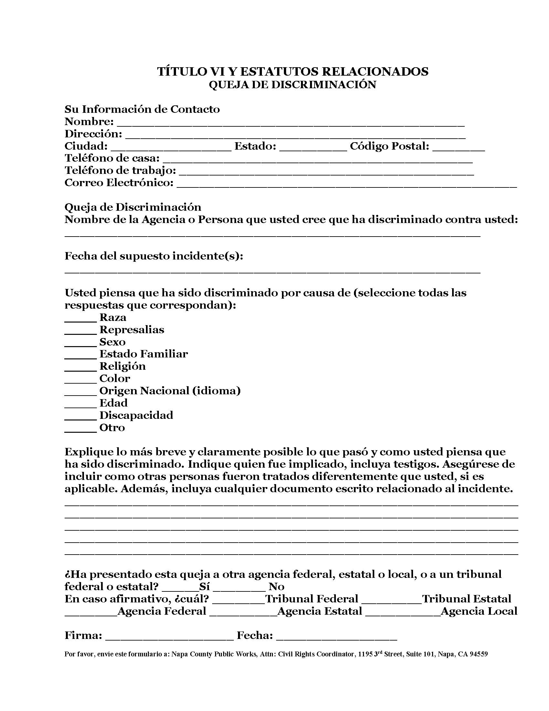

## **TITLE VI COMPLAINT FORM – TAGALOG**



# **Data Collection Procedures**

Napa County is required by federal regulation to collect statistical data on the race, color, and national origin of participants in and beneficiaries of its programs. Data collection efforts specific to each division and program area are described in the Department’s Goals and Accomplishment Report. The following is a brief description of the data collection activities conducted by the Department of Public Works.

* The Department uses review US census track data to determine the demographics of the area where a project is proposed. The demographics help inform outreach activities. If the information yields that persons residing in the project area speak a language other than English, the Department will make provisions to have translation/interpretation services available if requested.
* The Department sets an annual DBE goal and it is applied on a project- specific basis. The County reports the results at project close-out and provides an overall report annually on the progress made toward achieving the goal.
* The County conducts outreach to women-owned and minority owned businesses when soliciting bids and services. The County allows sufficient time for prime contractors to solicit participation from these firms so they can participate as a sub-consultant on the project team.
* The Title VI Program Manager tracks discrimination complaints and monitors their status and resolution.
* Staff track requests they receive from LEP persons for inquiries and services. Most of the divisions have bi-lingual Spanish speaking staff who are available to assist as needed. This information is compiled and reviewed by the Title VI Program Manager each year.

# **Title VI Training**

Napa County Public Works Department must take active steps to ensure that none of its activities or programs treats any part of a community any differently than another. The Napa County Public Works Department is committed to achieving full compliance and expects every manager, supervisor, employee, and sub recipient of federal-aid funds administered by the Napa County Public Works Department to be aware of and apply the intent of Title VI and related nondiscrimination statutes in performing assigned duties.

The Title VI Program Coordinator is responsible for scheduling and conducting training so that that County staff stay up to date with program requirements. The Title VI Training Program is designed to ensure that Department staff fully understand their responsibilities regarding these requirements, but most importantly, they understand that all community members must receive equal treatment and access to activities and programs. The training includes strategies and procedures to help ensure this happens.

The training focuses on orienting participants to the Department’s Title VI Program Plan. The training will also help them understand their responsibilities and improve their ability to respond effectively to a LEP person or an individual who may have a concern about being treated unfairly. We expect the training will take 1-1.5 hours. The training will include the topics described below. The order and time allocation for the topics may vary depending on the audience, time available and other factors.

**Training Program Topics:**

1. Introduction to the Department’s Title VI Program Plan

Participants will be introduced to the Title VI Program Plan and be given an orientation to the plan components and the laws and regulations that direct these programs.

2. Review of the Department’s programs and activities

Participants will review the Department’s programs and activities and discuss how the Title VI requirements might apply to their job. Participants will be asked to identify potential opportunities for interaction with LEP persons or individual who may have concerns about the response or treatment they are experiencing.

3. Review of outreach materials and complaint reporting procedures

Participants will receive information about how the County publicizes its responsibilities and complaint procedures. They will also receive information on how to file a complaint.

4. Discussion of potential responses

Potential responses will be discussed so participants can respond effectively to a LEP person or an individual with concerns.

5. Review of data collection and reporting procedures

The Department is required to report on its goals and accomplishments on an annual basis and update the Title VI Program Plan every three years or sooner if there are deficiencies or improvements that necessitate an update to the plan. There are also data collection procedures and reports that need to be addressed. Staff awareness and understanding of these procedures will help support the Title VI Program Manager’s ability to meet the requirements.

6. Review of Justice Department Videos

The US Justice Department is a definitive source of information regarding the Title VI requirements and they provide informational videos to help agency staff and interested parties stay informed regarding the requirements. The three (3) training videos identified below will be incorporated into the training- with time for discussion and reflection as time allows.

* [Understanding and Abiding by Title VI of the Civil Rights Act of 1964](https://youtu.be/lw0mefqIZ5Y) Department of Justice, Online Video
* [Breaking Down the Barriers: Translating Limited English Proficiency Policy into Practice](https://www.justice.gov/crt/videos), Department of Justice, Online Video, (English, Spanish, Chinese, Vietnamese, and Korean)
* [Overcoming Language Barriers, Department of Justice,](https://www.justice.gov/crt/video/overcoming-language-barriers-creating-language-access-policies)Online Video

**Training Program Participants:**

It is essential that County staff are aware of their responsibilities and receive training on a regular cycle. Training Program participants can be divided into two tiers. Tier 1 includes all staff from the divisions within the Department of Public Works. Tier 2 includes Napa County leadership including the Chief Executive Officer, County Counsel, Finance, Human Resources, and the Auditor.

**Training Program Schedule:**

Training will be conducted on a regular cycle. The Title VI Training videos provided by the US Justice Department will be included in the on-boarding process for new employees. Some of the Tier 1 employees will receive training during March 2018. Training will be provided for Tier 1 and Tier 2 staff every two years, with an emphasis on any updates to the federal requirements.

# **Annual Accomplishments Report**

|  | **Goals – 2018** | **Accomplishment** | **Status** |
| --- | --- | --- | --- |
| **1** | **Conduct outreach activities to County staff and public to ensure broad awareness of Title VI Program requirements** |  |  |
|  | * Place posters (English, Spanish and Tagalog) in prominent locations in county offices and public areas of buildings * Use regular meetings of staff and management on a quarterly basis to refresh staff awareness of Title VI program requirements * Post posters on County website (English, Spanish and Tagalog) * Reach out to community partners and share posters and information * Conduct outreach to contractors and consultants regarding Title VI assurance contracting requires for: Compliance with regulations, non-discrimination, solicitations for sub-agreements and information and reports * Respond to inquiries as needed | * Posters placed in public and internal areas of County buildings * Title VI will be a standing agenda item as of March 2018 * Poster in (English, Spanish and Tagalog) posted on County website * Contractors will receive outreach as part of County notification and solicitations process * County will respond to contracting requirements as required | * Completed * Completed * Completed * Ongoing * Ongoing |
|  |  |  |  |
| **2** | **Conduct training activities for DPW staff and County Leadership** |  |  |
|  | * Conduct training for Public Works staff on a two-year cycle * Work with consultant to finalize training materials and program * Conduct training on a regular schedule with County leadership * Provide web-based training platform, including US Justice Department videos to train new staff as part of their on-boarding process. * Provide general handout to contractors and consultants and program requirements | * Staff training was conducted on March 21, 2018 and August 1, 2018 * Consultant hired February 2018 to develop materials * Scheduling initiated to determine when additional trainings can be conducted * Videos have been secured. County is exploring web platform for independent use of the training * Share handouts from trainings with contractors and consultants on an ongoing basis | * Completed * Completed * Ongoing * Ongoing * Ongoing |
|  |  |  |  |
| **3** | **Provide translation/interpretation services** |  |  |
|  | * Translate Title VI information into Spanish and Tagalog | * Poster and complaint form translated into Spanish and Tagalog | * Completed |
|  | * Provide translation services as requested | * Bi-lingual staff have been identified and briefed regarding potential translation activities | * Ongoing |
|  |  |  |  |
| **4** | **Complete documentation of complaints and resolution as needed** |  |  |
|  | * Document complaints and resolution as needed | * Title VI Program Manager addresses these as needed. No complaints pending | * No activity at this time |
|  | * Document any program enhancements and adjust training program as needed | * Title VI Program Manager will respond as needed | * Ongoing |
|  |  |  |  |

# **APPENDIX**

Napa County utilizes various media to provide information to the public. See Attachments 1-7.